**“In Love We Share, In Love We Grow” Thematic Book Series**

*–* **Friendship is a Sheltering Tree** *–*

**(Pre-reading)**

1. **Teamwork**
2. **Do you prefer working in a team or by yourself? Why?**

I prefer working in a team / by myself (* *Circle your option.*) because ____________________________

_____________________________________________________________________________________

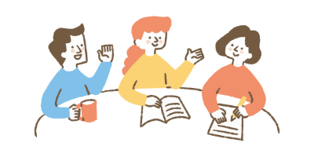

1. **Reflect on your experience working with friends or classmates on a group project. Are there things you achieved together that would have been impossible to accomplish alone?**

1. **Have you ever worked with friends or classmates who didn’t help out as much or at all? How did that make you feel, and what did you do about it?**

**(While-reading)**

1. **The Value of Friendship**

What made Lucas understand the importance of friendship? As friends of Lucas, what qualities did Joe and Emma show?

1. Analyse how Emma and Joe helped Lucas understand the importance of friendship by completing the chart below.  
   * Circle the correct answers and use the words provided in the box to fill in the blanks.

|  |  |  |  |  |  |  |
| --- | --- | --- | --- | --- | --- | --- |
| apologised | caring | cleaned | comforted | grateful | helpful | indifferent |
| kind | on his own | prepared | refused | self-centred | supporting | tripped |

|  |  |  |
| --- | --- | --- |
| **BEFORE** |  | **AFTER** |
|  | **CHANGE** |  |
| 1. Lucas ____________ to help Emma and Joe clean up the litter. 2. He continued the expedition _________________, leaving Emma and Joe behind. 3. He was ____________ and ____________.   **Lucas understood / did not understand the importance of friendship and teamwork.**  * | 1. Lucas ____________ over a stone and was injured. 2. Joe and Emma ____________ Lucas. 3. They ____________ Lucas’ wound and found a place for him to rest. 4. They set up the tent and ____________ the meal.   **Lucas was touched by his friends who are** ____________**,** ____________ **and** ____________**.** | 1. Lucas ____________ for his behaviour. 2. He realised the importance of having friends and the beauty of ____________ each other. 3. He was ____________ for Joe and Emma’s help.   **Lucas understood / did not understand the importance of friendship and teamwork.**  * |

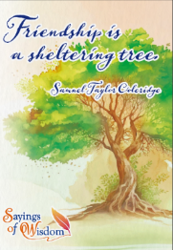

1. **Sayings of Wisdom**

|  |  |  |
| --- | --- | --- |
| 1. Find a metaphor for friendship from the story. |  | 1. Give one example from the story that illustrates the metaphor. |
|  |  |  |
|  |  |  |
|  |  |  |

1. What did Emma mean when she said “Many hands make light work”?

1. Think back to fun times you have spent with your friends. Can you remember moments that show the meaning behind these sayings of wisdom? Share your stories below.

**(Post-reading)**

1. **Dialogue Tags**Dialogue tags, also known as speech tags, are verbs or phrases used to identify the speaker in a conversation. These tags can appear before, after or even in the middle of the spoken words. They are useful for conveying the speaker’s tone, emotions or manner of speaking.  
   * + 1. Identify the dialogue tags used on pp.16-17 and pp.24-26.

|  |  |  |
| --- | --- | --- |
| **verb** | **verb + adverb** | **verb + with + noun** |
|  |  |  |
| * + - 1. Complete the summary cloze using the dialogue tags from the table above. As Lucas frantically searched his room, he (i) _________________________, “I can’t believe I lost your favourite book!”   Joe smiled and (ii) _________________________, “It’s alright, Lucas. We can look for it together!”  “I’m so sorry, Joe,” (iii) _________________________ Lucas.  They rummaged through the piles of clothes and books. Lucas walked around the room and (iv) _________________________, “Where can it be?”  Suddenly, Joe (v) _________________________, “Look! There it is, under the bed!”  Lucas’ face lit up and he (vi) _________________________, “We found it! I was so worried!”  Joe (vii) _________________________, “I knew we’d find it eventually.” | | |

1. **Resolving Disagreement**

Although Lucas refused to clean up the litter, Joe and Emma did not get mad at Lucas or argue with him. They continued to show their care and support for Lucas when he was injured.

1. In pairs, discuss the following questions with your partner.
2. Would you respond the same way as Joe and Emma? Why or why not?
3. Recall an incident when you disagreed with your friend. Describe what happened and how it ended.
4. Did your relationship change after the incident? If given another chance, how would you resolve the conflict? The following STAND Conflict Resolution framework may be helpful.

**STAND Conflict Resolution\***

**Your Reflection**

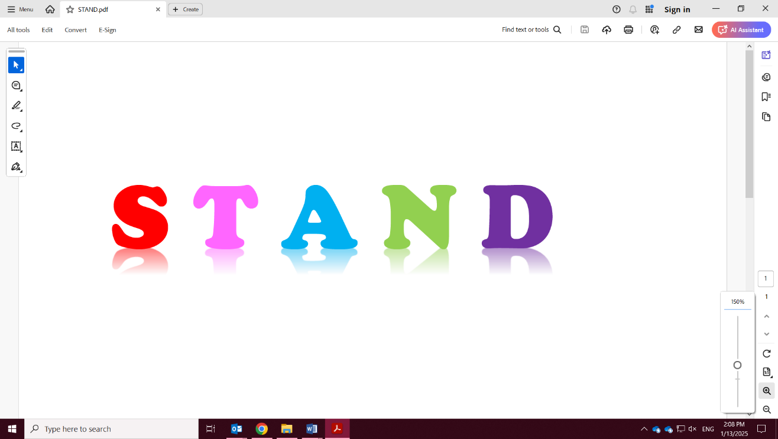

 **top and calm down**

* stay calm and manage your feelings

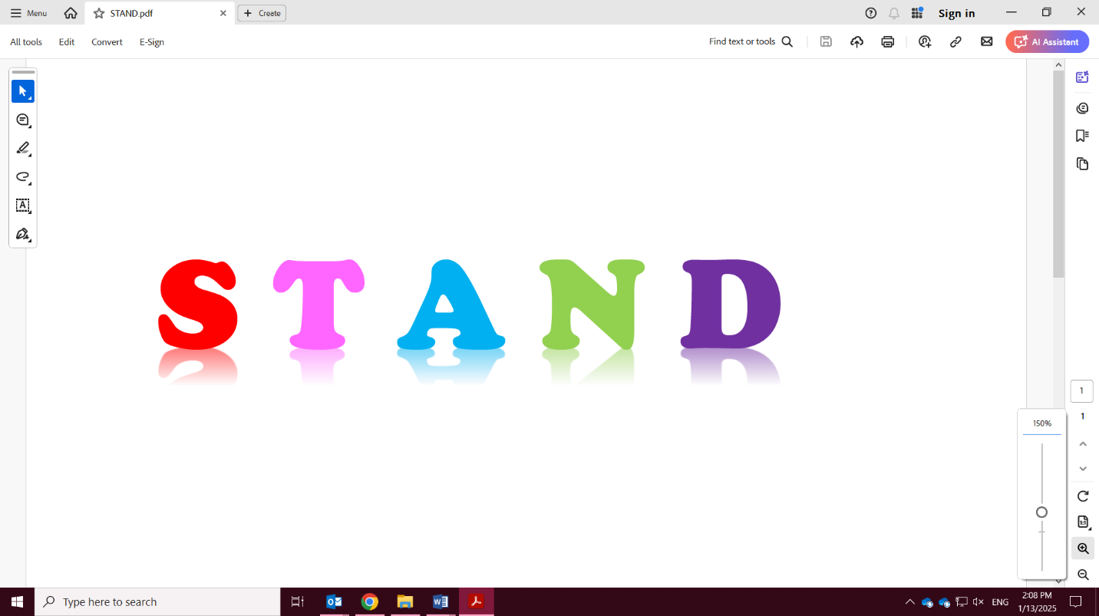

**alk about the problem**

* take turns to explain the problem and how you want to fix it
* listen attentively when the other is speaking
* use “I” to share your thoughts and feelings

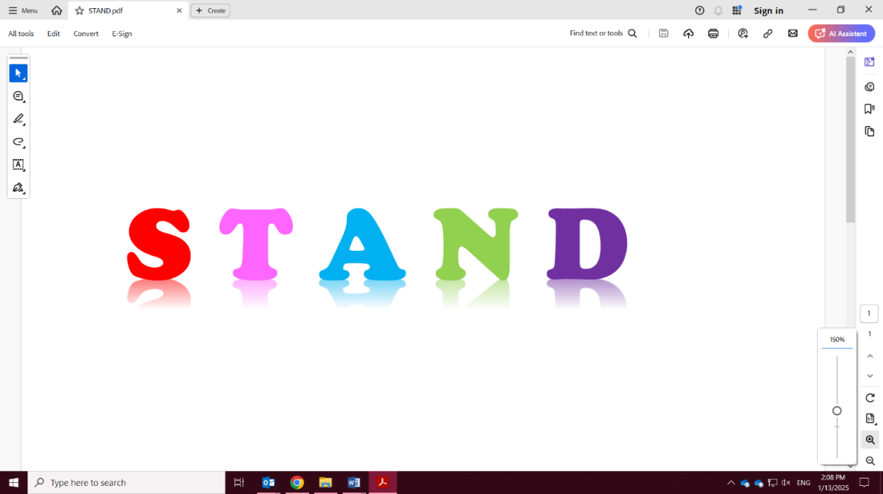

**sk for alternatives**

* brainstorm options for resolving the conflict

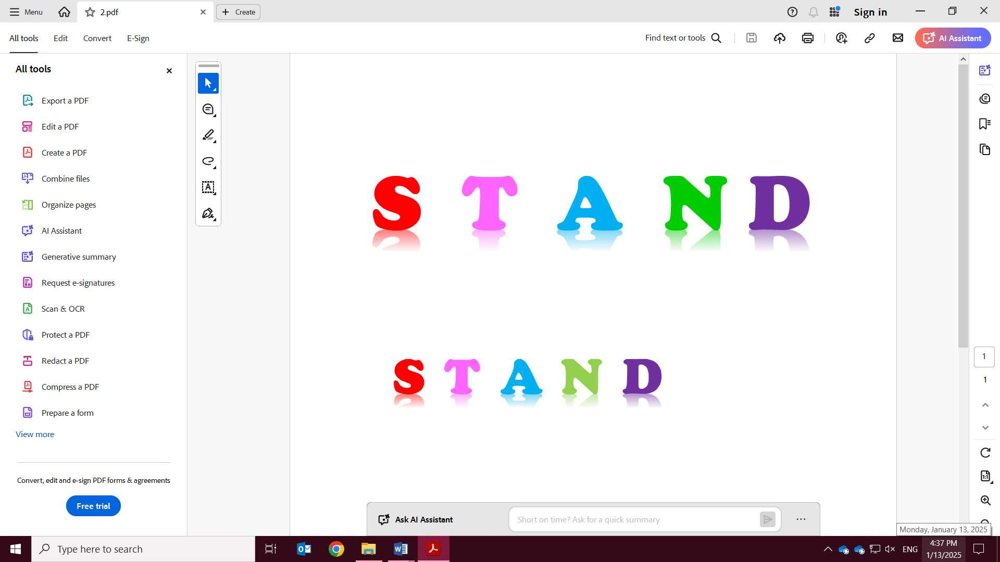

**arrow the choices**

* get rid of choices that are not okay for both of you
* avoid choices that are unsafe or against rules

  
 **ecide on the best solution**

* think about what will happen with each choice you consider
* weigh the pros and cons of each choice

**\*Borba, M. (2014, March 26). *Conflict resolution for kids*.**

https://micheleborba.com/building-moral-intelligence-and-character/michele-borba-blog-teaching-kids-to-solve-conflicts-peacefully/