**“In Love We Share, In Love We Grow” Thematic Book Series**

*–* **To Love Oneself is the Beginning of a Lifelong Romance** *–*

**(Pre-reading)**

1. 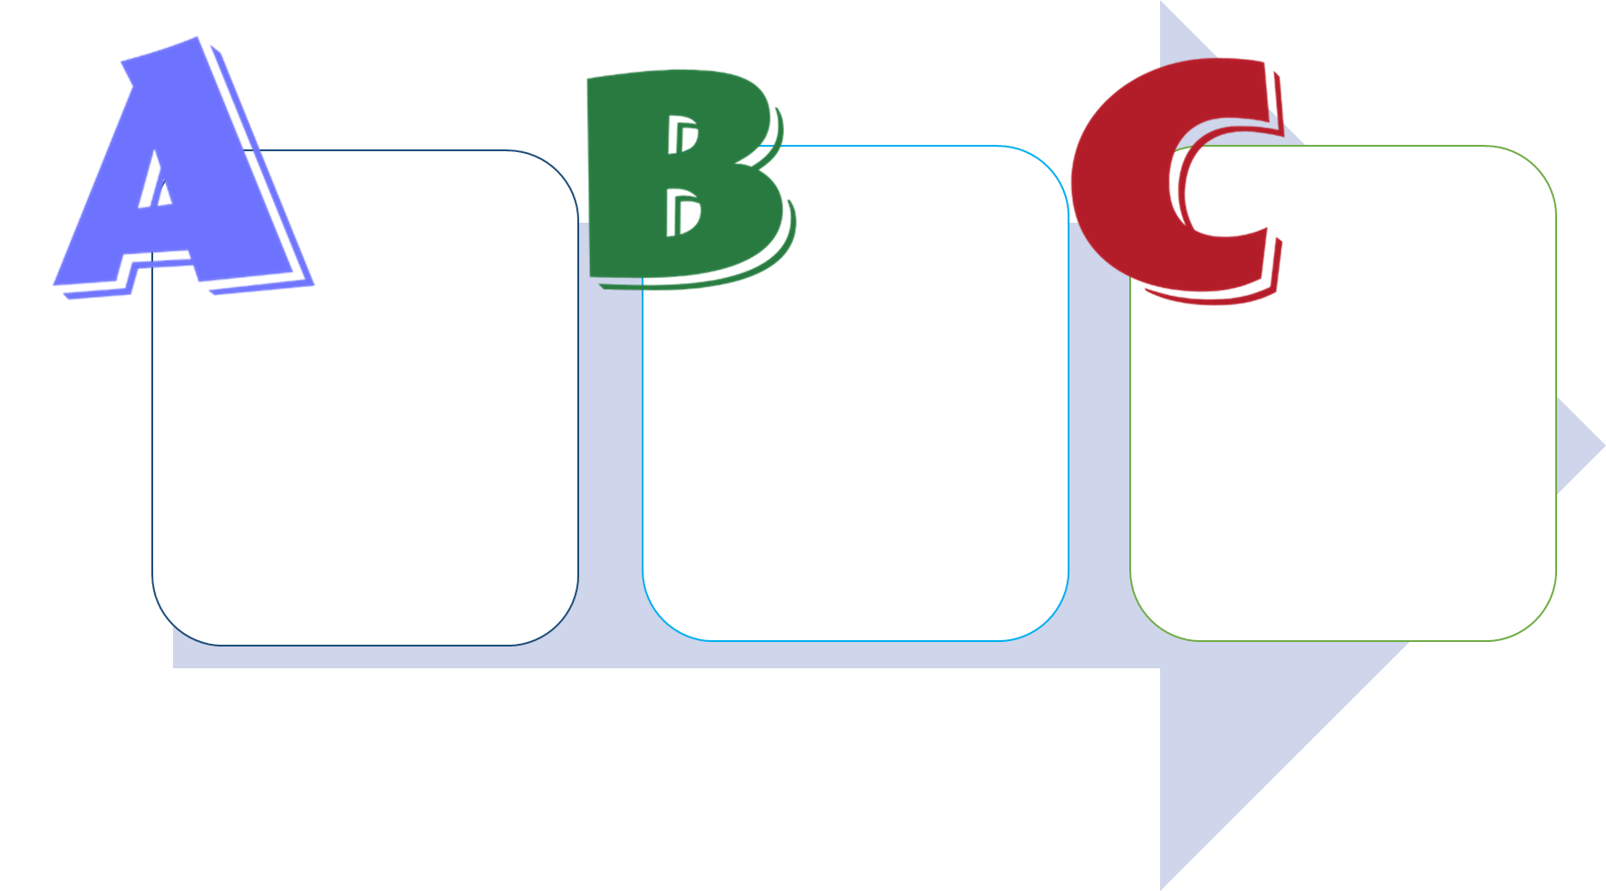**Facing Adversity**
2. When was the last time you felt sad? Complete the chart below and share your experience with the class.

**Consequence**

**Belief**

**Adversity**

b) How did you manage your negative emotions?

d) What happened in the end?

1. When was the last time you felt sad?

*Accept any reasonable answers.*

*Accept any reasonable answers.*

*Accept any reasonable answers.*

e) How would you describe the consequence resulted?

c) How would you describe your reaction to negative emotions?

* Positive □ Negative
* Rational □ Irrational

**(While-reading)**

1. **Emotional Management Skills**
2. 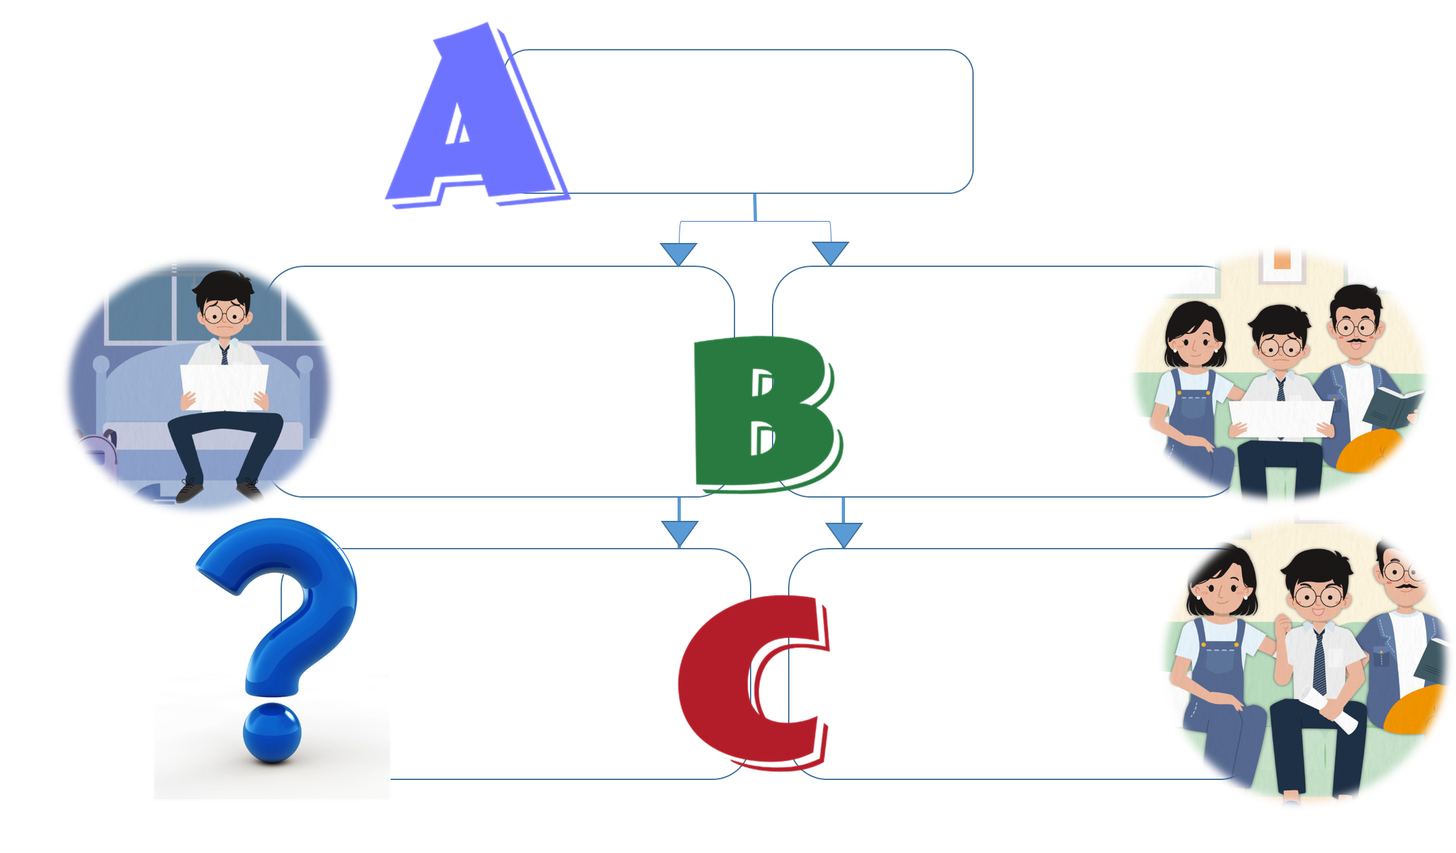Based on the development of the story, analyse Joe’s emotional responses using the ABC model*.

**Adversity**

1. What was the adversity faced by Joe?
2. What would possibly happen if Joe did not properly handle his negative emotions?

*Accept any reasonable answers.*

positive

manage

2.

Rational beliefs can help _________________ our emotions and lead to _________________ consequences.

*his work was not comparable to the winners’*

*very frustrated*

b) Joe believed that ____________

___________________________

___________________________.

c) He felt _____________________.

**Belief**

* Tiba AI (2024). The Grounded Cognition Foundation of the First Cognitive Model in Cognitive Behavior Therapy: Implications for Practice. *Front. Psychol.* 15:1364458.doi: 10.3389/fpsyg.2024.1364458.

**Consequence**

* *Go to art exhibitions./*
* *Watch online tutorials./*
* *Do more practice.*

1. Predict what Joe would do next. Give one example.

**Negative**

**Positive**

**Rational**

**Irrational**

*Joe failed to win any awards in the competition.*

*seek help from his parents*

*share his feelings with his parents*

1. Joe opted to:

* _______________________

_______________________;

* _______________________

_______________________.

1. 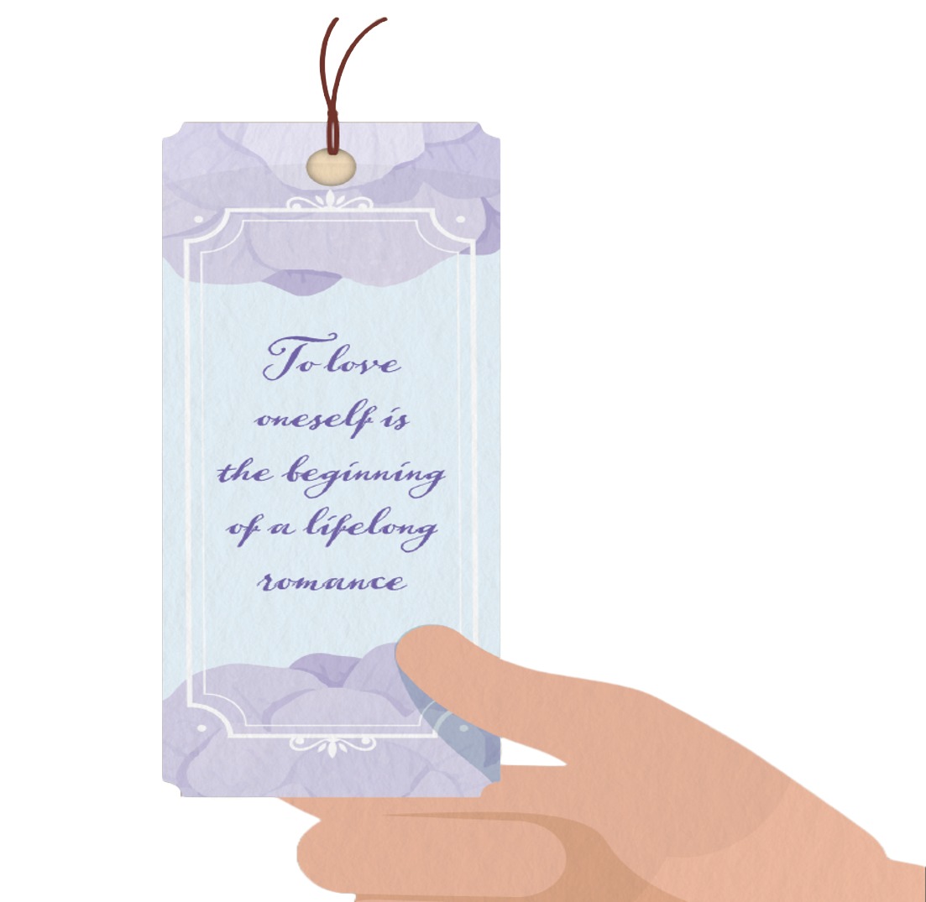**Sayings of Wisdom**

2. How did Mum guide Joe to equip himself for his artistic journey?

1. How did Dad encourage Joe to appreciate his own ability?





* Mum encouraged Joe to:
  + learn from masterpieces displayed in exhibitions;
  + watch online tutorials;
  + do more practice;
  + learn from new ideas.
* Art could be valued in many ways.
* Joe’s painting had its own style.

**(Post-reading)**

1. **Inflectional -ed Endings**
2. Work in pairs. Read aloud the following words to your classmate. Pay attention to the “-ed” endings and complete the table according to their ending sounds. You may refer to the e-book for the pronunciation of these words again.

arrived rushed submitted looked talented failed

satisfied frustrated opted shared dropped listened

studied explained picked showed asked spilled

turned added valued explained passed amazed

encouraged guided suggested prepared added experienced

|  |  |  |
| --- | --- | --- |
| When “-ed” is added to the word, it makes a _____ sound. | | c) When “-ed” is added to the word, the ending consonant forms **a syllable** with the ending consonant. |
| 1. **/t/** | 1. **/d/** |
| * rushed * looked * dropped * picked * asked * passed * experienced | * + arrived   + failed   + satisfied   + shared   + listened   + studied   + explained   + showed   + spilled   + turned   + valued   + explained   + amazed   + encouraged   + prepared | * submitted * talented * frustrated * opted * added * guided * suggested * added |

2a) When “-ed” is added to the following ending consonants, it makes a /t/ sound.

-sh, -k, -p, -s, -c(e)

b) Read aloud these ending consonants again, what feature do they share in common?

They give a/an voiced / aspirated * sound. (* *Circle the answer.*)

3a) When “-ed” is added to the following ending consonants/vowels, it makes a /d/ sound.

-v(e), -y/i, -r(e), -n, -w, -l, -u, -z(e), -g(e)

b) Read aloud these ending consonants/vowels again, what feature do they share in common?

They give a/an voiced / aspirated * sound. (* *Circle the answer.*)

1. When “-ed” is added to the following ending consonants, it forms a syllable with the ending consonant.

-t, -d

1. **Facing Adversity**
2. How did Joe face adversity?
3. When Joe felt sad, he opted to ___________________________ from his parents.

seek help



positive

b) Dad guided Joe to stay ______________________ and appreciate the effort Joe had made in his artwork.





inspired

relieved

improve

c) Mum guided Joe to explore ways to ______________________ his art techniques.

d) Joe felt ______________________ and was _____________________ to fight for his new goals.

1. Joe opted to talk to his parents when he felt sad. What other ways would you recommend to Joe to help him face adversity? Explain your answers.

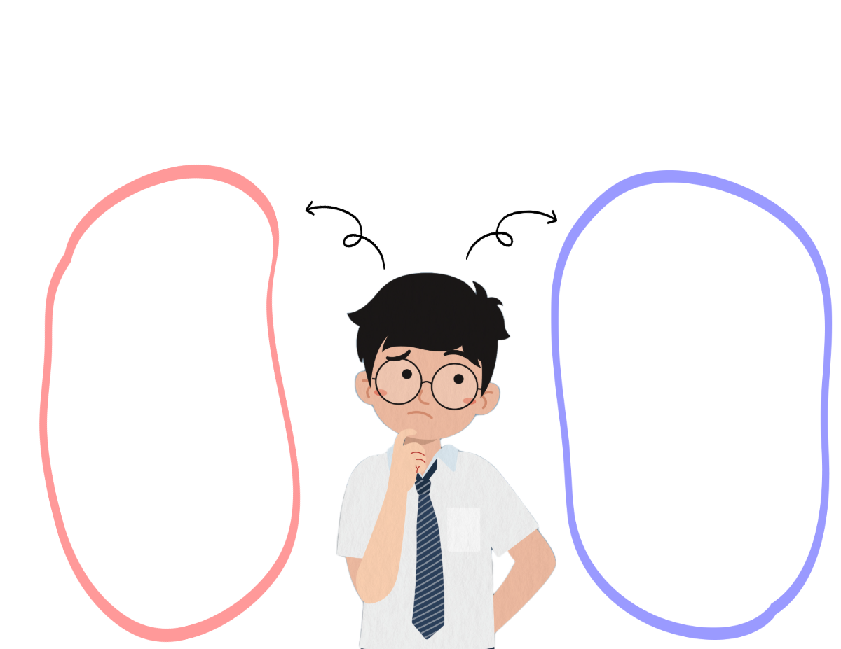

*Accept any reasonable answers.*

*Accept any reasonable answers.*

b)

a)