**“In Love We Share, In Love We Grow” Animation Series**

*–* **Friendship is a Sheltering Tree** *–*

**(Pre-viewing)**

1. 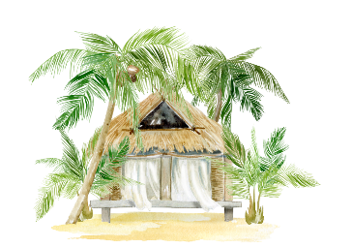In the saying “Friendship is a sheltering tree”, how is friendship compared to a sheltering tree?
2. What is the figurative language used in the phrase “Friendship is a sheltering tree”?

**(While-viewing)**

During their hike in the country park, Emma, Joe, and Lucas observed irresponsible behaviours among other hikers. Watch the video and answer the following questions:

|  |  |
| --- | --- |
|  | 1. Emma saw litter left by other hikers and decided to clean it up. Will you help her? *(Video Time: 01:23 – 01:46)* |

|  |  |
| --- | --- |
|  | 1. Two mischievous children were throwing stones at the birds and carving on the tree trunks. Will you stop them? *(Video Time: 02:40 – 02:57)* |

1. Write down two examples of “friendship as a sheltering tree” from the video.

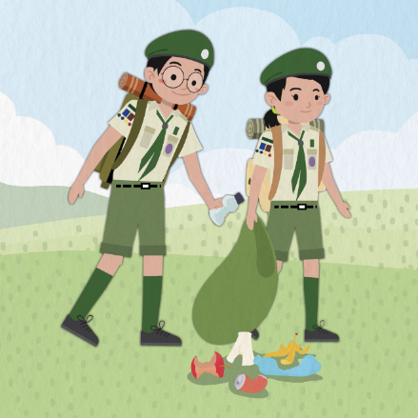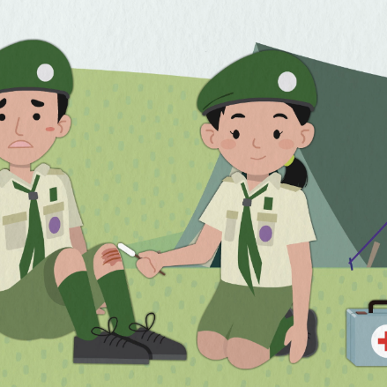

1. How did Emma, Joe, and Lucas respond differently when they saw litter everywhere in the country park? Quote their responses. Also, why do you think they reacted differently? How did their reactions reflect their personalities and the different values they held? *(Video Time: 01:23 – 02:38)*

|  |  |  |  |
| --- | --- | --- | --- |
|  | **Emma** | **Joe** | **Lucas** |
|  |  |  |  |
| Responses |  |  |  |
| Lines |  |  |  |
| Personalities & Values |  |  |  |

**(Post-viewing)**

1. Write a blog post as if you were Lucas to describe how your experience today has inspired you.

