**“In Love We Share, In Love We Grow” Animation Series**

*–* **To Love Oneself is the Beginning of a Lifelong Romance** *–*

**(Pre-viewing)**

|  |  |  |  |
| --- | --- | --- | --- |
|  | What does it mean when someone said he/she had been on “an emotional roller coaster” for the day? |  | 1. In the expression “an emotional roller coaster”, how is “emotions” compared to “a roller coaster”? 2. What language technique is used in the description “an emotional roller coaster”? |

**(While-viewing)**

**Feeling positive**

(*Video Time: 03:28 – The end*)

1. Use an adjective to describe Joe’s feeling at the end of the story?
2. 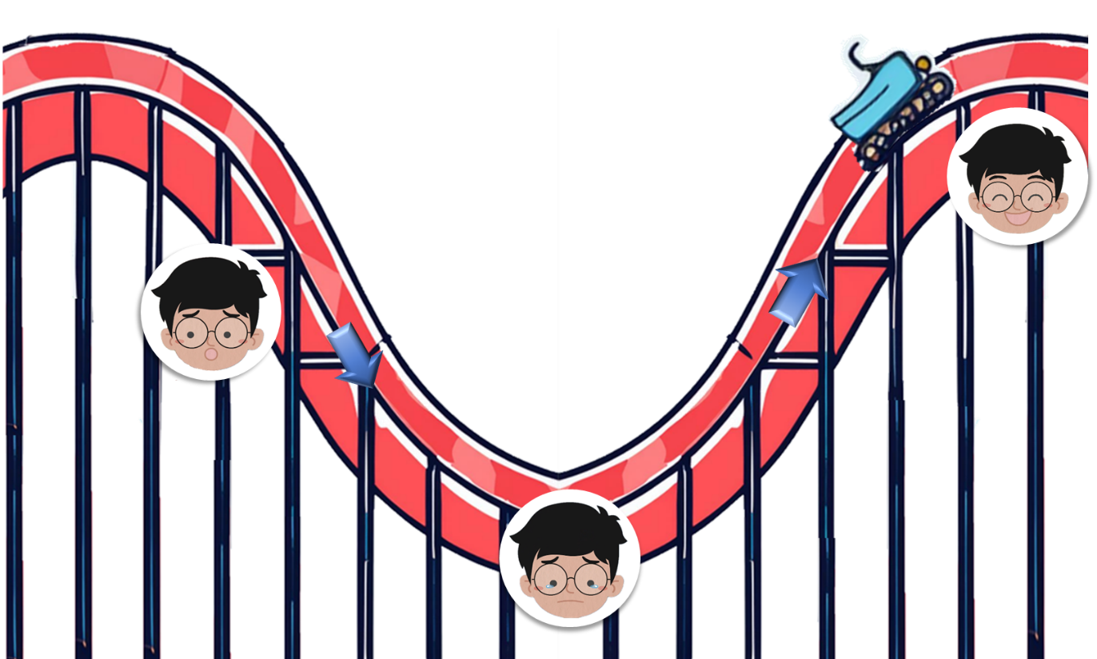Joe experienced an emotional roller coaster the other day. Watch the video and answer the questions:

**Background**

(*Video Time: 00:00 – 00:43*)

1. What did Joe think about his art techniques?

|  |
| --- |
| Before the competition |
|  |
| After the competition |
|  |

**Joe’s Emotional Roller Coaster**

**Learning to improve** (*Video Time: 02:41*)

1. If you were Joe, what would you do to improve your art techniques?

**Feeling sad** (*Video Time: 00:43*)

b) When you feel sad, how would you make yourself feel better?

**(Post-viewing)**

1. 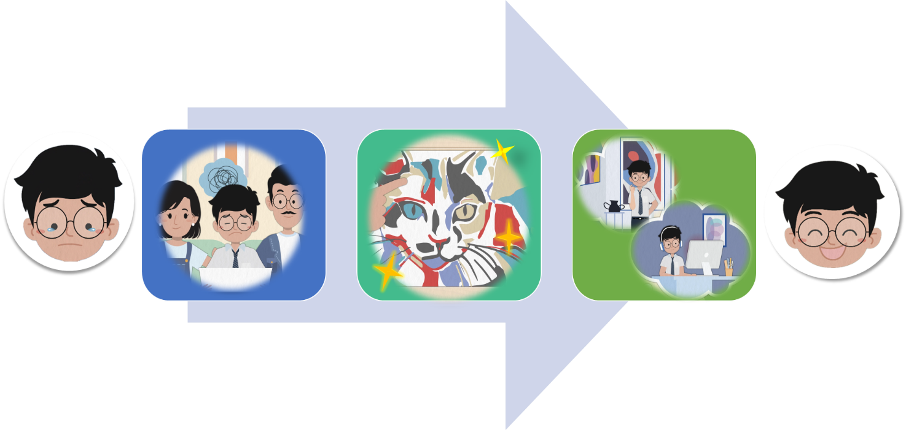How did Joe cope with his negative emotions?

**To Love Oneself is the Beginning**

**of a Lifelong Romance**

c)

b)

a)

.

;

;

Joe tried to

1. What is the meaning of the saying “To love oneself is the beginning of a lifelong romance”?
2. What are the film techniques used in the video to convey meaning?

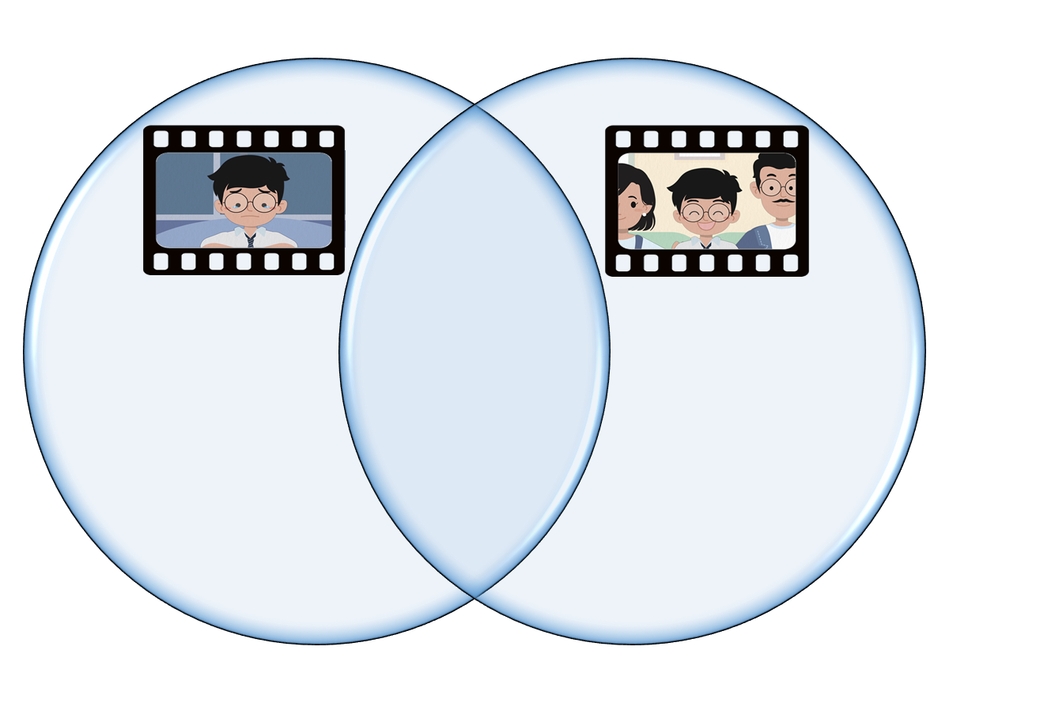

1. What is the use of a close-up shot in these two scenes?
2. Describe the colours used in the background when Joe felt relieved.
3. Describe the colours used in the background when Joe felt sad.
4. Have you experienced an emotional roller coaster before? Describe your experience and how you coped with the negative feelings.