**“In Love We Share, In Love We Grow” Animation Series**

*–* **To Love Oneself is the Beginning of a Lifelong Romance** *–*

**(Pre-viewing)**

|  |  |  |  |
| --- | --- | --- | --- |
|  | What does it mean when someone said he/she had been on “an emotional roller coaster” for the day?  He/She experienced emotional highs and lows/ ups and downs/ mood swings/ both positive and negative emotions on that day. |  | 1. In the expression “an emotional roller coaster”, how is “emotions” compared to “a roller coaster”?   The experience of emotional ups and downs is like riding on a roller coaster, going up and down.   1. What language technique is used in the description “an emotional roller coaster”?   Metaphor |

**(While-viewing)**

**Feeling positive**

(*Video Time: 03:28 – The end*)

1. Use an adjective to describe Joe’s feeling at the end of the story?

Relieved/happy/relaxed/

energetic

1. 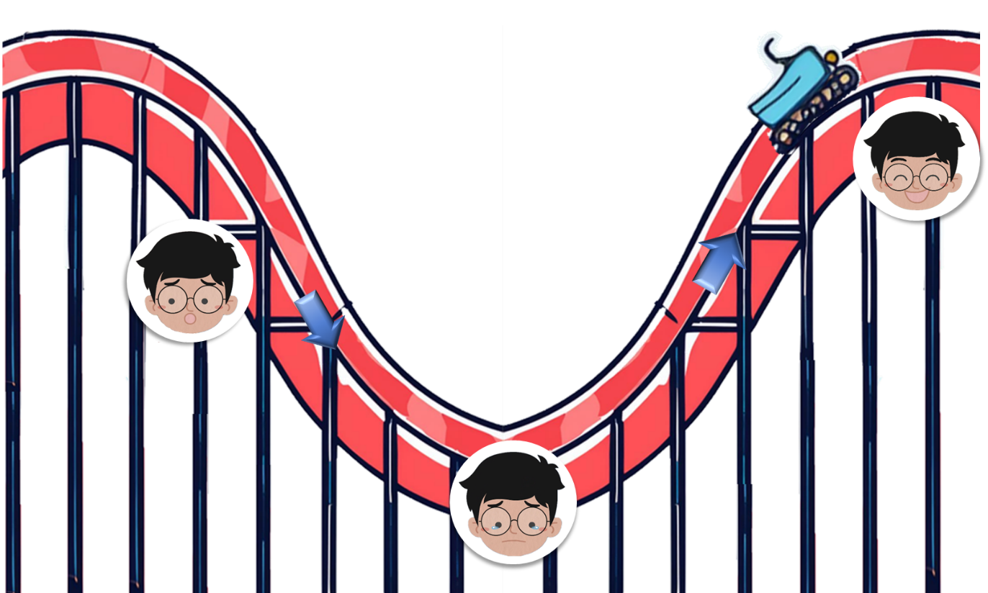Joe experienced an emotional roller coaster the other day. Watch the video and answer the questions:

**Background**

(*Video Time: 00:00 – 00:43*)

1. What did Joe think about his art techniques?

|  |
| --- |
| Before the competition |
| He was confident in his art techniques. /  He believed that he was artistically talented. |
| After the competition |
| He was not satisfied with his performance and felt very frustrated. |

**Joe’s Emotional Roller Coaster**

**Learning to improve** (*Video Time: 02:41*)

1. If you were Joe, what would you do to improve your art techniques?

Accept any reasonable answers.

**Feeling sad** (*Video Time: 00:43*)

b) When you feel sad, how would you make yourself feel better?

Accept any reasonable answers.

**(Post-viewing)**

1. 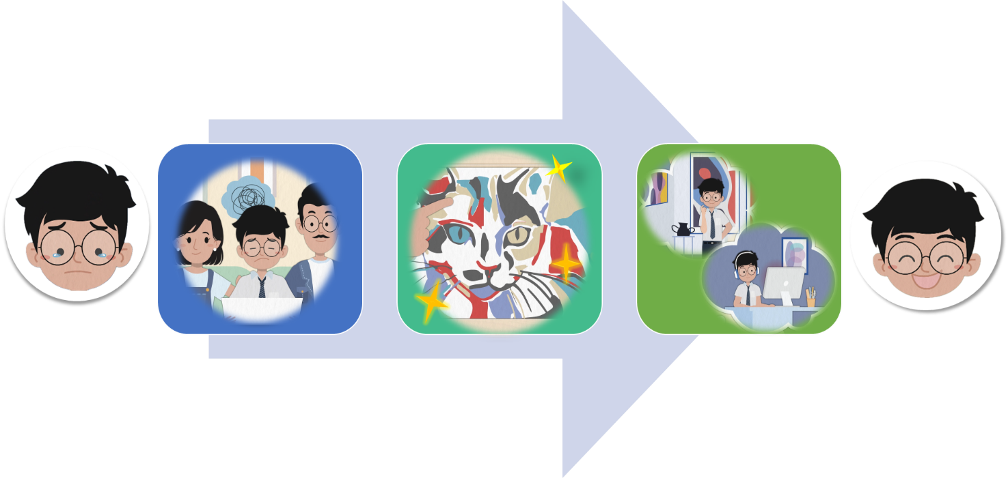How did Joe cope with his negative emotions?

**To Love Oneself is the Beginning**

**of a Lifelong Romance**

improve/ strengthen himself (by improving his art techniques)

c)

a)

b)

;

.

embrace something positive in the situation

get support (from his parents)

;

Joe tried to

1. What is the meaning of the saying “To love oneself is the beginning of a lifelong romance”?

We are encouraged to love ourselves by accepting who we are, which leads us to a lifelong journey of self-discovery.

1. 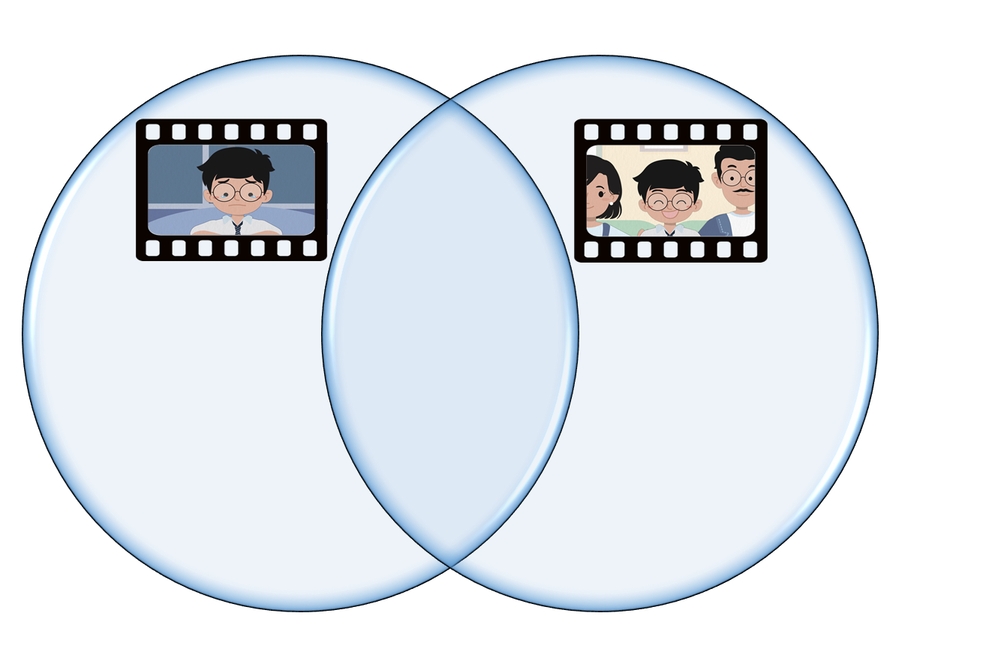What are the film techniques used in the video to convey meaning?
2. What is the use of a close-up shot in these two scenes?
3. Describe the colours used in the background when Joe felt sad.
4. Describe the colours used in the background when Joe felt relieved.

To draw viewers’ attention to the characters’ feelings.

Dull/dark colours are used to represent sadness/create a sad/gloomy atmosphere.

Bright colours are used to represent happiness/create a positive atmosphere.

1. Have you experienced an emotional roller coaster before? Describe your experience and how you coped with the negative feelings.

Accept any reasonable answers.