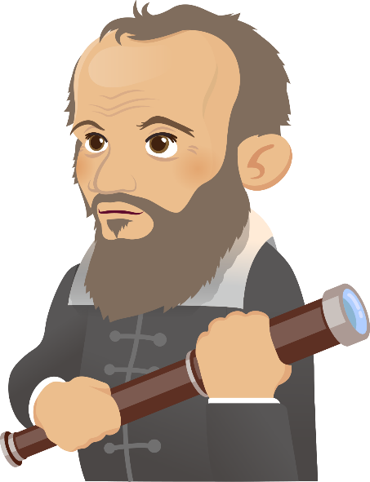
The Biography of Galileo Galilei

1. Galileo Galilei was an influential Italian scientist and an expert in astronomy, physics and philosophy.

Early life
2. Galileo was born in Pisa, a city of Italy, in 1564. His father was a music teacher and a famous musician. Galileo was an excellent student and wanted to become a doctor.

Achievements
3. Later, however, he studied philosophy and mathematics and became a professor of mathematics in 1592. He used scientific methods to do experiments. For example, he studied the speed of objects falling from the Leaning Tower of Pisa and proved that traditional beliefs were wrong.

4. In 1609, Galileo made many astronomical discoveries and became famous. He first heard of an invention of a telescope from Holland. Then he improved the design of the telescope and began to use it to view the planets. He saw mountains and valleys on the surface of the moon. He also saw sunspots and four largest moons of the planet Jupiter.

Imprisonment
5. In 1614, Galileo supported the Copernican theory and believed that the Sun was at the centre of the solar system. Although everyone supports the theory today, it was a different idea at that time. The Church was powerful at that time and considered his idea as heresy. He was even stopped from teaching these theories.

6. In 1632, he published a book called “Dialogue Concerning the Two Chief World Systems” to explain the arguments for and against the Copernican theory. He was accused of heresy by the Church again. He was sentenced to life imprisonment and also forced to withdraw his support for the theory.

Death
7. When Galileo was under house arrest, he published another book “Two New Sciences” in 1638. He was named the “father of modern physics” because of this book. However, he went blind since then and died in 1642 at the age of 77.
1

Other information

The Copernican Theory is a theory introduced by a Polish astronomer called Nicolaus Copernicus. His study led to his theory that the Sun is the centre of the universe, and the planets orbit around it.

Glossary

- astronomy: (noun) the study of the Sun, stars, planets, and other natural objects in space

- physics: (noun) the study of matter and energy

- philosophy: (noun) It is a way of thinking about the world, the universe, and society

- a professor: (noun) a teacher especially at a college or university

- a planet: (noun) an extremely large, round mass of matter, such as Earth or Mars, that moves around the Sun or another star

- surface: (noun) the outside/outer part of something

- the solar system: (noun) The solar system consists of the Sun and everything that travels around the Sun, including the eight planets and their moons.

- heresy: (noun) an opinion or belief that is the opposite of or against what is the popular opinion

- publish: (verb) print or release a book for public sale

- an argument: (noun) a reason or reasons why you support or oppose an idea or suggestion

- life imprisonment: (noun) to put someone in prison for the rest of his/her life as a punishment
2

- Read the biography of Galileo Galilei. Complete the timeline by choosing the correct event from the table below. The first one has been done as an example.

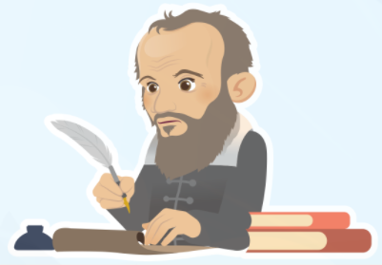
The Timeline of Galileo Galilei
(a)
(d)
(e)
(f)
(g)
(b)
(c)
1564

1592

1609

1614

1632

1638

1642

3
improved the telescope to study planets and stars  He made many astronomical discoveries. He improved the design of the telescope and discovered the uneven surface of the moon. | died at the age of 77 | supported the Copernican theory  He supported the Copernican theory that the Sun was at the centre of the solar system. It was different from the view of most people at that time, who believed that the Earth was in the central position.
( ) | ( ) | ( )
became a Mathematics professor  He did experiments to test the speed of different objects that were dropped off from the Leaning Tower of Pisa. It disproved Aristotle’s theory that heavier objects would fall faster than lighter objects. | born in Italy  His father was a music teacher and a famous musician. Galileo was an excellent student and wanted to become a doctor. | “Father of modern physics”  He published another book called “Two New Sciences” under house arrest and soon went blind. He was named the “father of modern physics” because of this book.
( ) | e.g. ( a ) | ( )
sentenced to life imprisonment
He published a book called “Dialogue Concerning the Two Chief World Systems”. He was sentenced to life imprisonment and forced to withdraw his support of the Copernican theory.
( )

- Here are the inventions and achievements of Galileo. Complete the missing information and description.
4
Year | Inventions/Achievements | Description
 | did experiments to test the traditional beliefs | During the time of Galileo, people studied the works of classical philosophers and believed them to be true. However, Galileo tested the principles by doing ___________________.  One traditional belief was that if you dropped two items of different weights, the heavier item would land first. Galileo tested the idea by going to the top of the Leaning Tower of ______. It was found that balls with different weights landed at the same time.
1609 | ______________ the design of telescopes | Galileo heard of an invention from Holland called the telescope that enabled the user to see objects from far away. So he built his own telescope. He made improvements to the telescope and began to use it to see the _________.
 | supported the Copernican theory | Copernicus was an astronomer who lived in the early 1500s. He came up with the idea that the ___________ was the centre of the universe. However, most people thought that the ___________ was the centre at that time. Galileo began to study Copernicus’ works and felt that his observations of the planets supported the view that the Sun was the centre.
 | published the book “Two New Sciences” | Galileo promoted the ideas on the laws of motion and the principles of mechanics in the book. He was then named “father of modern _____________”.

- Complete the crossword puzzle below to revise the new vocabulary items you have learnt.
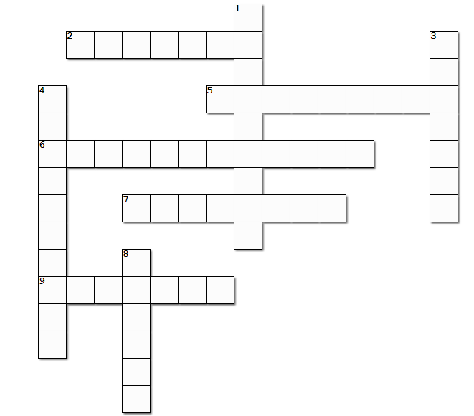
Down
1.  3.  4.  8. | the study of the Sun, stars, planets, and other natural objects in space  the outside/outer part of something  It is a way of thinking about the world, the universe and society.  an extremely large, round mass of matter, such as Earth or Mars, that moves around the Sun or another star
Across
2.  5.  6.  7.  9. | the study of matter and energy  a teacher especially at a college or university  the act of putting someone in prison as a punishment  a reason why you support or oppose an idea or suggestion  print and release a book for public sale

5

- Answer the following questions. For the multiple choice questions, circle the best answer.

- What kind of job did Galileo’s father do?
- a mathematics teacher
- a musician
- a professor
- a scientist

- How did Galileo study the speed of objects falling from the Leaning Tower of Pisa?
- He read books about traditional beliefs.
- He used his telescope.
- He did scientific experiments.
- He published a book.

- What could Galileo’s telescope be used to see?
- sunspots
- surface of the moon
- four moons of the planet Jupiter
- all of the above

- Why was Galileo in prison?
- His ideas were different from those of most people.
- He was dishonest and told lies.
- He withdrew his support of Copernican theory.
- He published a book called “Two New Sciences”.

- Which invention/theory developed by Galileo is most impressive to you? Why?

- What made Galileo a great scientist?

6
(Answer Key)
- Read the biography of Galileo Galilei. Complete the timeline by choosing the correct event from the table below. The first one has been done as an example.

The Timeline of Galileo Galilei
(a)
(d)
(e)
(f)
(g)
(b)
(c)
1564

1592

1609

1614

1632

1638

1642

7
improved the telescope to study planets and stars  He made many astronomical discoveries. He improved the design of the telescope and discovered the uneven surface of the moon. | died at the age of 77 | supported the Copernican theory  He supported the Copernican theory that the Sun was at the centre of the solar system. It was different from the view of most people at that time, who believed that the Earth was in the central position.
( c ) | ( g ) | ( d )
became a Mathematics professor  He did experiments to test the speed of different objects that were dropped off from the Leaning Tower of Pisa. It disproved Aristotle’s theory that heavier objects would fall faster than lighter objects. | born in Italy  His father was a music teacher and a famous musician. Galileo was an excellent student and wanted to become a doctor. | “Father of modern physics”  He published another book called “Two New Sciences” under house arrest and soon went blind. He was named the “father of modern physics” because of this book.
( b ) | e.g. ( a ) | ( f )
sentenced to life imprisonment
He published a book called “Dialogue Concerning the Two Chief World Systems”. He was sentenced to life imprisonment and forced to withdraw his support of the Copernican theory.
( e )

- Here are the inventions and achievements of Galileo. Complete the missing information and description.
8
Year | Invention/Achievement | Description
1592 | did experiments to test the traditional beliefs | During the time of Galileo, people studied the works of classical philosophers and believed them to be true. However, Galileo tested the principles by doing experiments.  One traditional belief was that if you dropped two items of different weights, the heavier would land first. Galileo tested the idea by going to the top of the Leaning Tower of Pisa. It was found that balls with different weights landed at the same time.
1609 | improved the design of telescopes | Galileo heard of an invention from Holland called the telescope that enabled the user to see objects from far away. So he built his own telescope. He made improvements to the telescope and began to use it to see the planets.
1614 | supported the Copernican theory | Copernicus was an astronomer who lived in the early 1500s. He came up with the idea that the Sun was the centre of the universe. However, most people thought that the Earth was the centre at that time. Galileo began to study Copernicus’ works and felt that his observations of the planets supported the view that the Sun was the centre.
1638 | published the book “Two New Sciences” | Galileo promoted the ideas on the laws of motion and the principles of mechanics in the book. He was then named “father of modern physics”.

- Complete the crossword puzzle below to revise the new vocabulary items you have learnt.

Down |  | Answers:
1.  3.  4.  8. | the study of the Sun, stars, planets, and other natural objects in space  the outside/outer part of something  It is a way of thinking about the world, the universe and society.  an extremely large, round mass of matter, such as Earth or Mars, that moves around the Sun or another star | astronomy  surface  philosophy  planet
Across |  | Answers:
2.  5.  6.  7.  9. | the study of matter and energy  a teacher especially at a college or university  the act of putting someone in prison as a punishment  a reason why you support or oppose an idea or suggestion  print and release a book for public sale | physics  professor  imprisonment  argument  publish

- Answer the following questions. For the multiple choice questions, circle the best answer.
- What kind of job did Galileo’s father do?
b. a musician
(Prompt: You can find clues in paragraph 2.)
- How did Galileo study the speed of objects falling from the Leaning Tower of Pisa?
c. He did scientific experiments.
(Prompt: You can find clues in paragraph 3.)
- What could Galileo’s telescope be used to see?
d. all of the above
(Prompt: You can find clues in paragraph 4.)
- Why was Galileo in prison?
- His ideas were different from those of most people.
(Prompt: You can find clues in paragraph 5.)
- Which invention/theory developed by Galileo is most impressive to you? Why?
(Accept any reasonable answers)

- What made Galileo a great scientist?
Galileo had a passion for science. He would not take traditional beliefs for granted, but would conduct research to seek the truth through doing experiments.
(Accept any reasonable answers)
9

