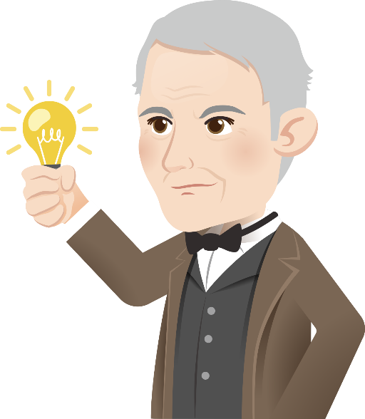
The Biography of Thomas Edison

1. Thomas Edison was a famous American scientist and inventor. He spent his whole life on inventions. He once said, "Genius is one per cent inspiration, ninety-nine per cent perspiration."

Childhood
2. Edison was born in the United States in 1847. When he was small, his school work was not very good and his teachers thought that he was not attentive in lessons. His mum decided to teach him at home. Later, he worked on trains to sell fruit and newspapers. At night, he did experiments and printed his own newspapers on the trains. However, he became partially deaf at the age of twelve because of scarlet fever.
Inventions
3. At the age of sixteen, Edison worked as a telegraph operator and invented an automatic repeater, which sent telegraph signals between unmanned stations. In 1868, he worked twelve hours a day on different experiments and inventions. He invented an electric vote recorder which made the voting process faster.

4. In 1876, he started his own laboratory and invented many things. For example, he invented the phonograph, which is the first machine that could record and play sound. He also invented the carbon microphone, which made the sound of the new telephone louder. He then made a ‘domestic’ light bulb that lasted longer. In 1884, he invented the electric power distribution network so that more people could use light bulbs at home.

Achievements
5. Edison passed away at the age of 84. Throughout his life, he developed and patented more than 1,000 inventions, which helped improve the modern lives of people around the world.
1

Other information:
Comparing Incandescent and LED light bulbs

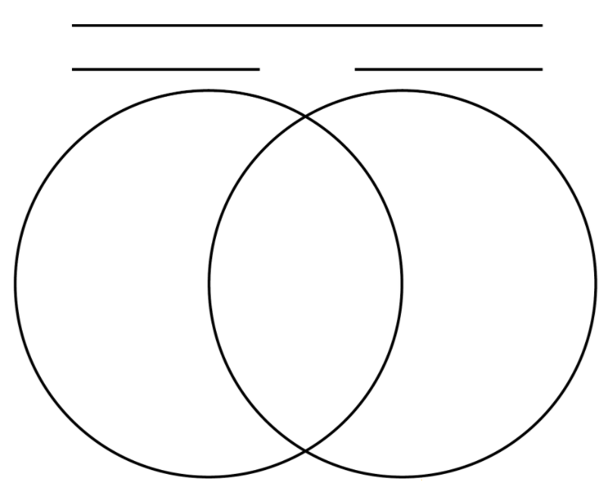
Ordinary (incandescent) light bulbs
Light emitting diodes (LED)
(Invented by Thomas Edison)
- cheaper
- 1,000 hours of lifespan
- made of glass and fragile
- low energy efficiency
- cannot be recycled
- It gets hot, with the risk of burnt fingers.
- more expensive
- durable, 25,000 hours of lifespan
- sturdy, made with epoxy lens
- energy saving
- recyclable
- It remains cool.
- can light up
- use electricity
- good for use at home and office
Glossary
- an inventor: (noun) a person who produces something, such as a useful device or machine for the first time through the use of the imagination and experiments.

- a genius: (noun) a very intelligent person who has exceptional skill in a certain area, e.g. Mathematics.

- inspiration: (noun) a force or an influence that makes someone want to do something

- perspiration: (noun) sweat, i.e. the salty liquid given off from skin

- deaf: (adjective) unable to hear

- scarlet fever: (noun) an illness which is most common in children 5 to 15 years of age. They usually suffer from a sore throat, a high fever and a red rash.

- a telegraph operator: (noun) a person who helps send messages using electric pulses in a special code

- a laboratory: (noun) a room or building in which people do scientific experiments and tests

- distribution: (noun) the way things are spread out and delivered

- to patent: (verb) to get a document that gives the inventor of something the right to be the only one to make or sell the invention

2

- Complete the graphic organiser which summarises the life and achievements of Thomas Edison.
Job: an ___________ / a scientist
Name: Thomas Edison
Place and date of birth:
in the ____________ _______________
in ___________
Family and education:
- His school work was not _________.
- His mum taught him at _________.

Early life:
- He worked on trains._________________________________________________________
- He did on trains.__________________________________________________
- He printed his own__________________________________________________________
- He became partially because of scarlet____________________________________

Edison’s achievements / inventions:
Edison
- invented an __________ ________ recorder in 1868.
- invented the _______________ that could record and play sound in 1876.
- invented the carbon ______________ , which made the sound of the new telephone louder.
- improved the design of the domestic .
- invented the electric power distribution network.
- patented more than ___________ ______________ that helped improve the lives of people.
______________________________
______________________________
______________________________
______________________________

Famous quote(s)

3

- Your friends think they have the following problems (a – e). Which quotes from Thomas Edison can best encourage them? Do the matching. The first one has been done for you as an example.

Types of Problems Faced |  |  | Encouraging Quotes
- I think I am not clever enough. |  |  | Opportunity is missed by most people because it is dressed in overalls and looks like work.
- I am learning how to ride a bicycle. I tried many times but was unsuccessful. I want to give up. |  |  | I have not failed. I’ve just found 10,000 ways that won’t work.
- I am a loser. I have not been given any chance/opportunity to be successful. |  |  | The three great essentials to achieve anything worthwhile are: hard work, stick-to-itiveness, and common sense.
- I failed in a science experiment and felt upset. |  |  | Our greatest weakness lies in giving up. The most certain way to succeed is always to try just one more time.
- I do not know how to be a successful person. |  |  | Genius is one per cent inspiration and ninety-nine per cent perspiration.
4

- Answer the following questions. For the multiple choice questions, circle the most suitable options.

- Who was Edison’s teacher when he was small?
- his father
- his mother
- his neighbour
- himself
- What problem did Edison face in his childhood?
- He did not like to learn and wanted to work.
- He was not clever enough.
- He did not learn well at school.
- He was not healthy enough.
- How long did Edison spend on doing experiments each day?
- 16 hours
- 12 hours
- 4 hours
- 1 hour
- What is a phonograph?
- It sends telegraph signals between unmanned stations.
- It makes the voting process faster.
- It can record and play sound.
- It makes the sound for the telephone louder.
- Which of the following is Edison’s invention?
- the fan
- the telephone
- the camera
- the electric vote recorder
5

- You have just moved to a new house. Your mum would like to buy some new light bulbs. She wants to buy LED light bulbs, but they are quite expensive. Give her some advice by comparing the ordinary and LED light bulbs.

- Edison invented more than 1,000 products. Which one do you think is the most important? Why?

- What made Edison a great scientist?

6

(Answer Key)
- Complete the graphic organiser which summarises the life and achievements of Thomas Edison.
Name: Thomas Edison
Job: an inventor / a scientist
Place and date of birth:
in the United States
born in 1847

Family and education:
- His school work was not very good/ outstanding.
- His mum taught him at home.

Early life:
- He worked on trains. ________________________________________________________________
- He did experiments on trains. ____________________________________________________
- He printed his own newspapers. __________________________________________________
- He became partially deaf because of scarlet fever. ____________________________________

Edison’s achievements / inventions:
Edison
- invented an electric vote recorder in 1868.
- invented the phonograph that could record and play sound in 1876.
- invented the carbon microphone, which made the sound of the new telephone louder.
- improved the design of the domestic light bulbs.
- invented the electric power distribution network.
- patented more than 1,000/one thousand inventions that helped improve the lives of people.
Genius is one per cent inspiration, ninety-nine per cent perspiration.

Famous quote(s)

7

- Your friends think they have the following problems (a – e). Which quotes from Thomas Edison can best encourage them? Do the matching. The first one has been done for you as an example.

Types of Problems Faced |  |  | Encouraging Quotes
- I think I am not clever enough. |  |  | Opportunity is missed by most people because it is dressed in overalls and looks like work.
- I am learning how to ride a bicycle. I tried many times but was unsuccessful. I want to give up. |  |  | I have not failed. I’ve just found 10,000 ways that won’t work.
- I am a loser. I have not been given any chance/ opportunity to be successful. |  |  | The three great essentials to achieve anything worthwhile are: hard work, stick-to-itiveness, and common sense.
- I failed in a science experiment and felt upset. |  |  | Our greatest weakness lies in giving up. The most certain way to succeed is always to try just one more time.
- I do not know how to be a successful person. |  |  | Genius is one per cent inspiration and ninety-nine per cent perspiration.

8

- Answer the following questions. For the multiple choice questions, circle the most suitable options.
- Who was Edison’s teacher when he was small?
b. his mother
(Prompt: You can find clues in paragraph 2.)
- What problem did Edison face in his childhood?
c. He did not learn well at school.
(Prompt: You can find clues in paragraph 2.)
- How long did Edison spend on doing experiments each day?
b. 12 hours
(Prompt: You can find clues in paragraph 3.)
- What is a phonograph?
c. It can record and play sound.
(Prompt: You can find clues in paragraph 4.)
- Which of the following is Edison’s invention?
d. the electric vote recorder
(Prompt: You can find clues in paragraph 3.)

- You have just moved to a new house. Your mum would like to buy some new light bulbs. She wants to buy LED light bulbs, but they are quite expensive. Give her some advice by comparing the ordinary and LED light bulbs. (accept any reasonable answers)

- Edison invented more than 1,000 products. Which one do you think is the most important? Why? (accept any reasonable answers)

- What made Edison a great scientist? (accept any reasonable answers)
He was hardworking and eager to learn even though the learning environment was not desirable. He was willing to spend long hours on different experiments and inventions.
9

