|  |  |
| --- | --- |
| **“Developing Students’ Listening and Viewing Skills” Video Series**  **– Jenny’s New Classmate –** | **Video Link:**    https://emm.edcity.hk/media/1_0rni67og |

**(Pre-viewing)**

1. Based on the video title “Jenny’s New Classmate”, what do you think the story might be about?

_____________________________________________________________________________

1. Below is one scene captured from the video. What kinds of challenges the boy might face in the story? (*You may tick more than one box.*)

□ Language barriers or misunderstandings

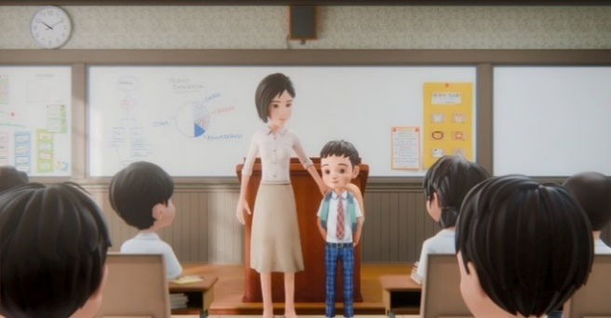

□ Feeling lonely or isolated  
 □ Academic struggles  
□ Cultural confusion  
 □ Homesickness  
□ Social acceptance  
 □ Understanding jokes or humour

□ Other: __________________________

**(While-viewing)**

**Watch the video “Jenny’s New Classmate”.**

1. Refer to the video segment (Video Time: 00:33 – 00:46).
2. 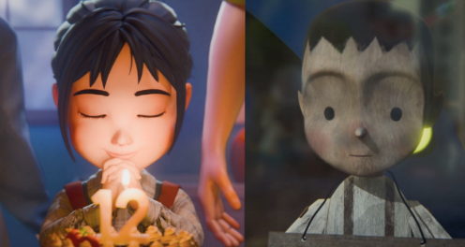A split screen is used to display two segments side by side with the images of (i) _________ (*on the left*) and (ii) ___________(*on the right*) to highlight the (iii) similarities/differences* in their wishes.

(\**Circle the correct answer.*)

1. What is common in Jenny’s and the toy’s wishes?

__________________________________________________________________________

1. Why do you think they had these wishes?

__________________________________________________________________________

1. Who is the narrator of the story?

__________________________________________________________________________

1. Refer to the video segment (Video Time: 00:47 – 00:55).
2. What do the arrow and light symbolise?

__________________________________________________________________

__________________________________________________________________

1. What was the angel trying to do to help Jenny and the toy?

_____________________________________________________________________________________________________

1. Refer to the video segment (Video Time: 00:56 – 01:22).
2. Listen carefully to how Jenny, Leon and other classmates spoke. Analyse how their tones reflected their feelings.

|  |  |  |  |  |
| --- | --- | --- | --- | --- |
| **Character** | **Line** | **Tone** | | **Feeling** |
| Leon | “Hello. I’m Leon. Let’s be friends.” | (i) □ warm  □ nervous  □ hesitant | □ observational  □ welcoming  □ curious | (ii) He felt ______________________  ______________________. |
| (*You may tick more than one box.)* | |
| Classmates | “Where’s he from?”  “He looks shy.” | (iii) □ warm  □ nervous  □ hesitant | □ observational  □ welcoming  □ curious | 1. They felt   ______________________  ______________________. |
| (*You may tick more than one box.)* | |
| Jenny | “Welcome to our school, Leon.” | (v) □ warm  □ nervous  □ hesitant | □ observational  □ welcoming  □ curious | 1. She felt ______________________   ______________________. |
| (*You may tick more than one box.)* | |

1. Refer to the video segment (Video Time: 01:23 – 01:51).
2. What were the two meanings of the expression “a walk in the park”?

Idiomatic meaning:   
 _____________________

Literal meaning:

walking in the park

1. Why was Leon confused after hearing the idiom “*a walk in the park*”?

____________________________________________________________________________________________________

An **idiom** is a group of words in a fixed order having a particular meaning (*idiomatic meaning*) that is differernt from the meaning of each word on its own (*literal meaning*). **Idioms** are commonly used in the English language for various purposes, such as making stories more engaging or colourful, strengthening or intensifying a point or capturing interest, especially in media and advertising.

1. Throughout the video, you will notice several idiomatic expressions. Pay attention to how these expressions are used in various contexts. Try to find out the idiomatic meaning in the following examples:

|  |  |  |
| --- | --- | --- |
| **Video Time** | **Idiom** | **Idiomatic meaning** |
| 0:26 | “Suki, I wish you **smooth sailing** on your new journey.” | having a/an (i) ____________________ experience |
| 2:41 | “We’ve **got your back**, Leon!” | (ii) _________________ somebody |
| 2:53 | “Yeah, you **went above and beyond** what we’d expected!” | (iii) ___________________ expectations |
| 3:14 | “Friends should stick together **through thick and thin**.” | supporting each other in both (iv)_____________ and (v) _________________ times |

1. Analyse the changes of Leon by completing the charts below:

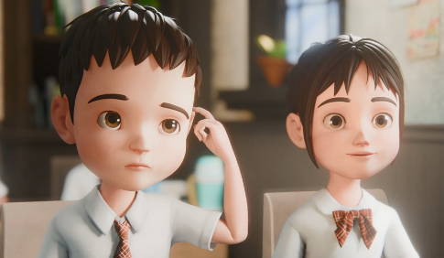

(Video time: 00:56 – 01:51)

(a) Leon:

* looked (i)__________________.
* (ii)_________________________ idioms   
  (e.g. a walk in the park).
* had (iii)__________________ barriers with his classmates.
* felt (iv) accepted/tired/isolated. (*Circle the correct answer.*)

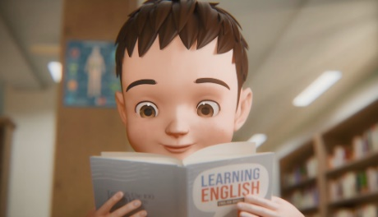

(Video time: 01:52 – 02:27 )

(b) Leon:

* learnt English and knew more about Jenny’s (i)_________________ through (ii)__________________ .
* showed talent for (iii)_______________.
* was (iv)_______________ to participate in class activities.
* built (v)____________________ with classmates.

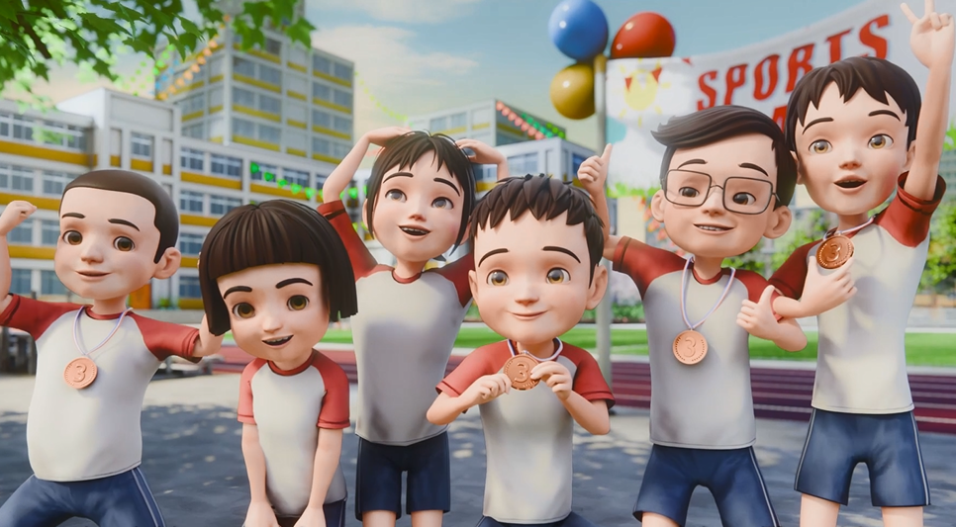

(Video time: 02:29 – 03:02)

(c) Leon:

* participated in a (i)___________________ with classmates.
* looked more (ii)____________________.
* (iii)________________________ idioms   
  (e.g. above and beyond).
* felt (iv) accepted/tired/isolated. (*Circle the correct answer.*)

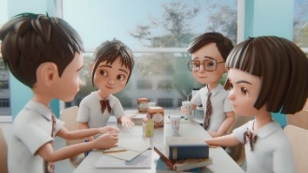

1. The arrow and light appeared again at the end of the video (Video Time: 03:18 – 3:22).   
   What is the purpose of this repetition?

__________________________________________________________________________________________________________________________________________________________

1. Where do you think Leon came from? Find one piece of evidence from the video to support your answer.

__________________________________________________________________________________________________________________________________________________________

(**Post-viewing)**

1. Imagine you are a student reporter for your school’s newsletter. You have been assigned to write an article about the annual sports day featuring Leon and his classmates. In your article, include:

* A catchy headline
* A summary of the relay
* A highlight on the value of teamwork
* A photo caption for a picture of a significant moment

