|  |  |
| --- | --- |
| **“Developing Students’ Listening and Viewing Skills” Video Series**  **– Survival –** | **Video Link:**    https://emm.edcity.hk/media/1_uv2e27ps |

**(Pre-viewing)**



1. **What does the word “Survival” mean to you?**

**After**

**Before**

**Human**

1. A “survivor” might have had a/an _______________________ experience.

**Human**

3) What will happen if someone “survives”? Give examples.

Survival

**Wildlife**

2) If an animal/a plant “survives”, it might have “survived” from _______________

______________ in the environment.

**Wildlife**

4) What will happen if an animal/a plant “survives”? Give examples.

1. **Play the video with the screen off and listen to the poem “Survival”.**
2. Focus on the **sound effects and audio elements** and identify the setting of the poem.

|  |  |  |
| --- | --- | --- |
|  | **Sound Effect** | **Setting of the Poem (Where?)** |
|  | (i) | (ii) |
|  | (i) | (ii) |
|  | (i) | (ii) |

1. **Read the poem aloud. Try to feel the mood and atmosphere of the poem.**

**Survival** Gillian Bickley

|  |  |
| --- | --- |
| 5 | Thank you trees for being there, for staying  when many of the friends you knew─  birds and butterflies ─ have gone;  for flourishing, even; growing old  where concrete buildings  are constantly knocked down. |
| 10  15 | How brave you are to survive  in a place where the air is foul  and the noise unnatural;  you who should normally expect  to stabilise your roots  in humid humming forests,  alive with the smells of  animal and vegetable life  (not the smells of mineral death, as here). |
| 20 | It is good to look down a street  and, amazed, to see you there,  solid and green and cool, uncompromised  by the advertising posters on your boles;  a promise  that, since there was a past,  there may quite possibly be a future too. |

|  |
| --- |
|  |
| First published by Proverse Hong Kong in Gillian Bickley's first poetry collection, "For the Record and other Poems of Hong Kong" (2003), supported by Hong Kong Arts Development Council |

1. Where is the poem set?

**Present**

**Past**

1. Read Stanza 2 again. Identify the imagery based on the different senses described in the stanza.

(b)

**Hearing**

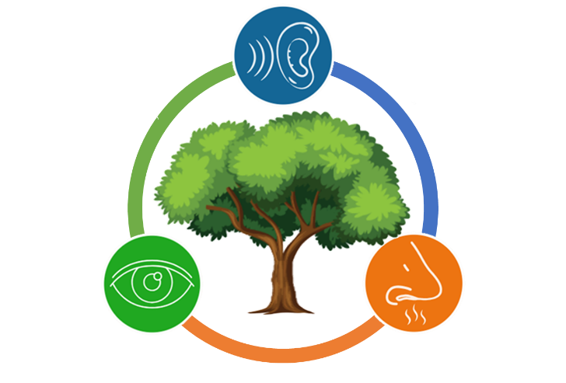

(a)

(c)

**Smell**

**Sight**

1. What is the challenge faced by the trees?

**(While-viewing)**

1. **Watch the video “Survival”.**
2. What is the poet’s attitude towards the trees? Quote examples from the poem to justify your choice.

|  |  |  |  |  |  |  |  |  |  |
| --- | --- | --- | --- | --- | --- | --- | --- | --- | --- |
| |  |  | | --- | --- | |  | 1. fearful | |  | 1. grateful | |  | 1. indifferent | |  | 1. critical | | Examples from the poem: |

1. Refer to the excerpt below (Video Time: 00:20-01:37).

|  |  |  |  |
| --- | --- | --- | --- |
|  | |  |  | | --- | --- | | 5 | for flourishing, even; growing old  where concrete buildings  are constantly knocked down. | |

|  |  |  |
| --- | --- | --- |
|  | **Background** | **Foreground** |
| 1. Identify the visual effects used in the excerpt. | (ii) Moving / Still * images are used in the **foreground.**   1. Slow / Fast * motion is used in the **background.** | |
| 1. What is the use of these visual effects? | The visual effect shows the changes in the (i) ___________________ over time. It includes different human activities which are (ii) ________________ to the trees. | Despite the changes happening in the surroundings, the trees still (iii) _______________________  __________________________. |
| 1. What is the purpose of using these visual effects? | The visual effects help   * create a (i) ________________ between the trees and the environment; and * highlight the trees’ (ii) ___________________ to challenges. | |

* *Circle the correct answer.*

1. Refer to the following excerpts. Identify the sound effect used in the underlined parts of the poem and its effects on the imagery and mood of the poem.

|  |  |  |
| --- | --- | --- |
| Video Time: 00:17 – 0:20 | Thank you trees for being there, for staying  when many of the friends you knew ─  birds and butterflies ─ have gone; | |
|  |  | |
| Video Time: 00:41 – 00:47 | you who should normally expect  to stabilise your roots  in humid humming forests, | |
|  | |



Mood

The use of (a) _______________

It creates a vivid image of (b) ____________.

It creates a (c) ______________ atmosphere.

Sound Effect

Imagery

1. Describe the relationship between the poet and the trees. Support your answer with reasons.

*The poet sees the trees as __________________. The reasons are as follows:*

1. Refer to the excerpt below (Video Time: 01:15-01:27) and analyse the poet’s attitude.

|  |  |  |  |
| --- | --- | --- | --- |
|  | |  |  | | --- | --- | | 20 | a promise  that, since there was a past,  there may quite possibly be a future too. | |

1. The poet is ___________________ about the future.
2. What does the word “*promise*” (Line 20) symbolise?
3. Explain the use of the three hedging words “*may quite possibly*” (Line 22) near the end of the poem.
4. What do the shooting stars appearing near the end of the video symbolise? Explain your answers.

**(Post-viewing)**

1. **Think about a time when you faced a challenging situation, much like the trees’ resilience to survive in a difficult environment in the poem.**

|  |  |
| --- | --- |
| My Future Self | 1. Write a letter to your future self. Describe a specific moment when you felt tested or overwhelmed. How did you feel at that time? 2. Reflect on how you managed to overcome or cope with that challenge. Did you draw strength from friends, family, or your own inner resources? 3. Encourage your future self with the lessons you learnt from the experience. |