|  |  |
| --- | --- |
| **“Developing Students’ Listening and Viewing Skills” Video Series**  **- A Typical Day in My Life -** | **Video Link:**    https://emm.edcity.hk/media/1_am9it5w2 |

**(Pre-viewing)**

1. **The thumbnail of a video is shown below. Look at the title and illustrations and predict the video’s content. Write TWO ideas in the space provided.**

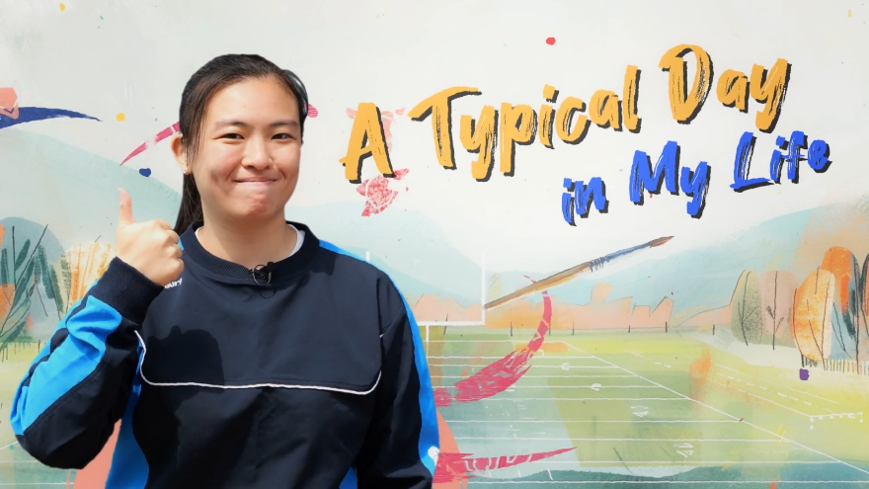



**(While-viewing)**

1. **Watch a video that showcases a day in the life of a local athlete named Mary Cheng. She talks about how she faced challenges because of her hearing loss. You can re-watch the video before answering any of the questions.**

|  |
| --- |
| **(Video Time: 00:09-00:59)** |
| 1) Workplace: _____________________________________________________  2) Occupation/Role: _________________________________________________  3) What she does at work: ____________________________________________ |

|  |  |  |
| --- | --- | --- |
| 4) Which of the following adjectives best describes Mary? **(Video Time: 00:33-00:43)**. | | |
| Tick the best option.   * A. ambitious * B. creative * C. excited * D. motivated | |  |
|  | | |
|
| **(Video Time: 01:00-01:54)** | | |
| 5) Workplace: _______________________________________________  6) Occupation/Role: ___________________________________________  7) What she does at work: ______________________________and______________________________  8) Decide if Mary is reporting a fact or an opinion. Tick the correct box for each excerpt:   |  |  |  | | --- | --- | --- | | **Excerpt** | **Fact** | **Opinion** | | 1. *Although over 90% of the staff here have different degrees of disabilities, after training, they work as chefs, cleaners, cashiers, and more.* |  |  | | 1. *They’re all kind and genuine.* |  |  | | | |
| *It’s inspiring to see them become self-reliant!*  9) What does “self-reliant” mean?  _________________________________________  _____________________________________________ |  | |

|  |  |  |  |  |  |  |  |  |  |  |  |  |  |  |  |  |  |  |  |  |
| --- | --- | --- | --- | --- | --- | --- | --- | --- | --- | --- | --- | --- | --- | --- | --- | --- | --- | --- | --- | --- |
| **(Video Time: 01:55-02:37)**    . 10) Organisation: __________________________________________  11) Location: _____________________________________________  12) Occupation/Role: _______________________________________  13) What she does: _________________________________________  14) Despite multiple challenges, Mary managed to find ways to overcome them. Complete the following table about how she overcame the hurdles and achieved success **(Video Time: 02:07-02:36)**.   |  |  | | --- | --- | | **Challenges** | **Solutions** | |  |  | | * Hearing (i) ____________________ * Unable to wear her (ii) __________________   ____________________ on the pitch   * Her coaches and teammates couldn’t understand (iii) ________________________ | * Rigorous (iv) ____________________ * Developed (v) _________________________   that allowed both the able-bodied and deaf players to effectively (vi) _________________  ______________________________________ |   15) Refer to the two excerpts below. Identify the type of framing used in the excerpts respectively. Describe how these types of framing are used and their purposes.   |  |  | | --- | --- | | **(Video Time: 02:31-02:35)** | **(Video Time: 02:40-02:45)** | | Type of framing used *\* (Circle only one answer.)* | | | (i) Wide shot / Medium shot / Close-up shot * | (ii) Wide shot / Medium shot / Close-up shot * | | Uses of this type of framing | | | * To show a whole (iii) ___________________ or object and its surroundings * Often used to give context to a scene | To show people’s (iv) ______________________  ____________________ or important details that help tell the story | | Purposes of using this type of framing | | | It captures moments of (v) ____________________________________ between Mary, her coach and teammates during training. | It captures Mary’s face and shows (vi) _________  ________________________________________  ________________________________________. |   16) Name the language features of the underlined parts.  *Don’t be afraid to try new things. We shouldn’t let our worries hold us back from living our lives to the fullest. We’ll never know until we try, right? Dream big and go for it!*  _________________________________________________  17) What is the tone used in the excerpt? Tick the best option.   * A. arrogant * B. compassionate * C. encouraging * D. sincere   18) Based on your responses to 16) and 17), explain Mary’s character and personality.  _____________________________________________________________________________________ |

**(Post-viewing)**

1. **Take a moment to recall and reflect on the different challenges you faced recently and how you dealt with them. Then, complete a flowchart with the topic “My Success Story”. Share your story with a classmate after finishing your chart.**

**My Success Story**

**Solutions**

**Success**

**Challenges**





1. **Express your gratitude to Mary in writing for the inspiration her experience has given you.**

Dear Mary,