ETV on Short Film Appreciation (II): Snap Chat
Learning Activity Sheets (for English Language Students)

This set of materials is designed to support the learning and teaching of the English Language curriculum at the secondary level. The aim is to promote students’ viewing and writing skills, and enhance their critical thinking capability.

This set of materials contains the following:
- Student’s copy
- Teacher’s notes (with suggested answers)
- A short film titled “Snap Chat”

They are intended for use by English Language teachers to provide guidance to secondary students on how to appreciate films and write a film review. The materials can be used as a learning task in class to introduce the different elements of a film and the text structure and language of a film review, or as supplementary materials to extend students’ learning beyond the classroom and promote self-learning.

Writing a Film Review: Snap Chat
Learning Activity 1: General Information of the Film
Watch the short film “Snap Chat” and complete the following table. You may need to watch it more than once.
Title
Year of Release
Genre
Director
Length
Cast / Character | Jamie Putnam as Jacob  Bryony Morgan as Brian  Justin Wong as Jonathan | Yu Kakinoki as Yolanda  Niamh Tair as Mia

Learning Activity 2: Understanding and Summarising the Plot
Part A: Number the pictures in the order of appearance and answer the questions that follow.
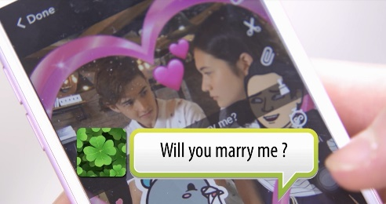
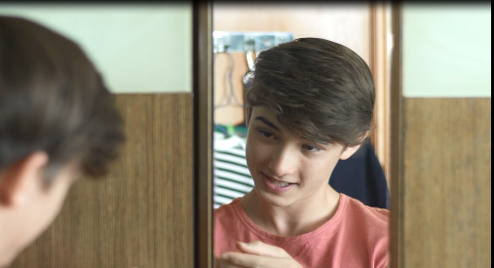 |  | 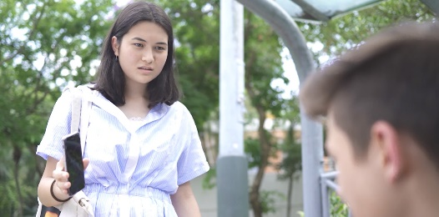
 |  | 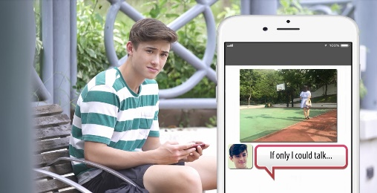

1. | Where is the film set?
2. | Who are the main characters?
3. | What happens in the opening of the film?
4. | How is the story told in the film?

Part B: Analyse the plot using the four key stages of the plot structure.
Stage 1 The Beginning
Where does the story begin? What characters are introduced? How are they introduced?
Stage 2 The Conflict
What are the events that lead to the main problem of the story?
Stage 3 The Climax
What is the main problem of the story? What is the most intense moment of the story?
Stage 4 The Resolution
How does the conflict end? What happens to the characters at the end?

Learning Activity 3: Describing a Scene
Describe the following scene. Use the present tenses and participles, if applicable. You may describe the characters’ facial expressions and body language.

Select a scene in the short film which impresses you most and describe it.
Scene _______________ (indicate the time)

Learning Activity 4: Analysing Filmic Elements
Watch the following excerpts from the short film and describe the editing, music and sound effects used, and explain their functions. Some examples are provided for you.
Duration | Filmic Elements | Functions
0:29 – 0:55 | Music and sounds: | to complement Jacob’s brisk daily routines
0:28 – 0:55 | Editing:  rapid cuts to show the actions in a disjointed way
1:47 – 2:08 | Music:
2:10 – 2:25 | Sounds: | to emphasise the absence of verbal communication among a group of friends sitting around the same table
3:10 – 3:52 | Editing:  alternating different scenes that are happening at the same time
4:41 – 4:45 | Music:

Learning Activity 5: Identifying Themes and Messages
Identify the theme of the short film “Snap Chat” by writing down (an) appropriate theme word(s) and a theme statement.

Theme word(s) |  | Theme statement

Learning Activity 6: Writing a Film Review
Write a film review on the short film “Snap Chat”.
Snap Chat ( |  |  |  | )
Director:

