Parent Education Resource Package for Primary Schools

Fostering happy development of children through synergy in parenting:

How to enhance collaboration between parents?

Worksheet on Praising Strengths

**Objective:** To help parents grasp how to appreciate and affirm their partner’s efforts in caring for their children, so that parents can maintain a positive partnership in caring for their children.   
  
**Activity:** Reflect on your partner’s inner strengths and look for behaviours that reflect these strengths in daily life.   
  
**Activity Duration:** About 5 minutes  
  
**Instructions:** When praising and affirming your partner’s efforts, parents need to specifically and clearly point out their partner’s positive behaviours and link such behaviours to their partner’s inner strengths. Which of the following 24 inner strengths do you think your partner has? Please circle three of your partner’s inner strengths (circle three white boxes) and record the behaviours your partner has performed to show these strengths over the past month.

Gratitude

Humour

Spirituality

Optimism

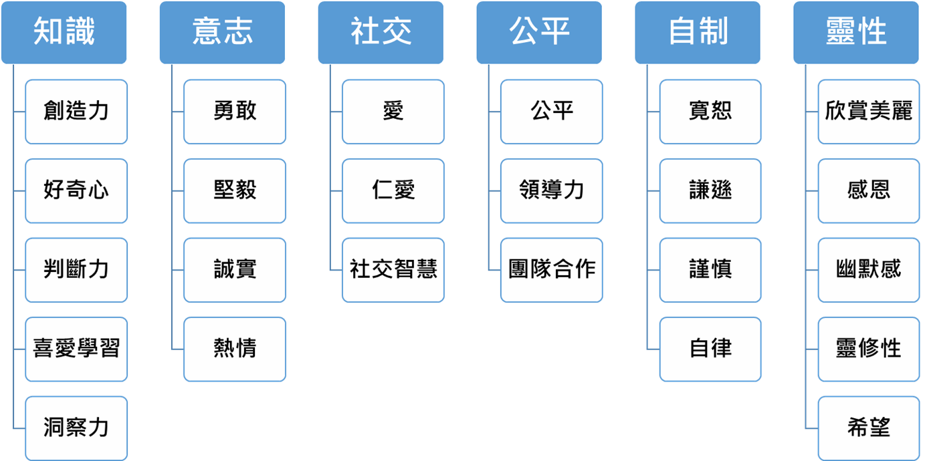

Perspective

Perspective

Knowledge

Hope

Spirituality

Humour

Gratitude

Appreciation of beauty

Spirituality

Prudence

Self-regulation

Humility

Forgiveness

Self-control

Teamwork

Leadership

Fairness

Fairness

Social intelligence

Kindness

Love

Social

Willpower

Bravery

Perseverance

Integrity

Zest

Creativity

Curiosity

Judgement

Love of learning

Link your partner’s behaviours with their inner strengths:

|  |  |
| --- | --- |
| Inner strength | behaviour |
| Example: Love of learning | My partner attends parent seminars on Sundays to learn how he/she can support our children’s development. |
| Strength 1: |  |
| Strength 2: |  |
| Strength 3: |  |