**Parent Education Resource Package for Primary Schools**

**Teaching children to be active learners:**

**How to support children in acquiring the generic skills for the 21st century?**

**Worksheet on Creative Thinking Exercise**

**Objective:** Try to solve the problem under specific conditions.

**Activity Duration:** About 10 minutes

**Task 1:** Please connect the 9 dots with **5 straight lines.** The tip of the pen/pencil cannot leave the paper during the process.

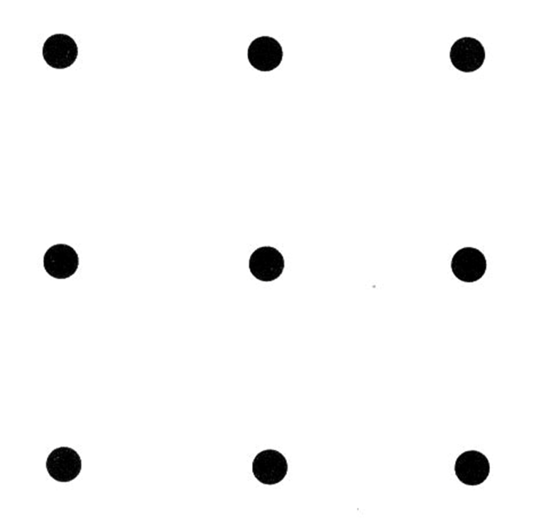

**Task 2:** Please connect the 9 dots with **4 straight lines.** The tip of the pen/pencil cannot leave the paper during the process.



**Task 3:** Please connect the 9 dots with **1 straight line**. The tip of the pen/pencil cannot leave the paper during the process.

