中國語文（一）

（非華語學生適用）

課冊

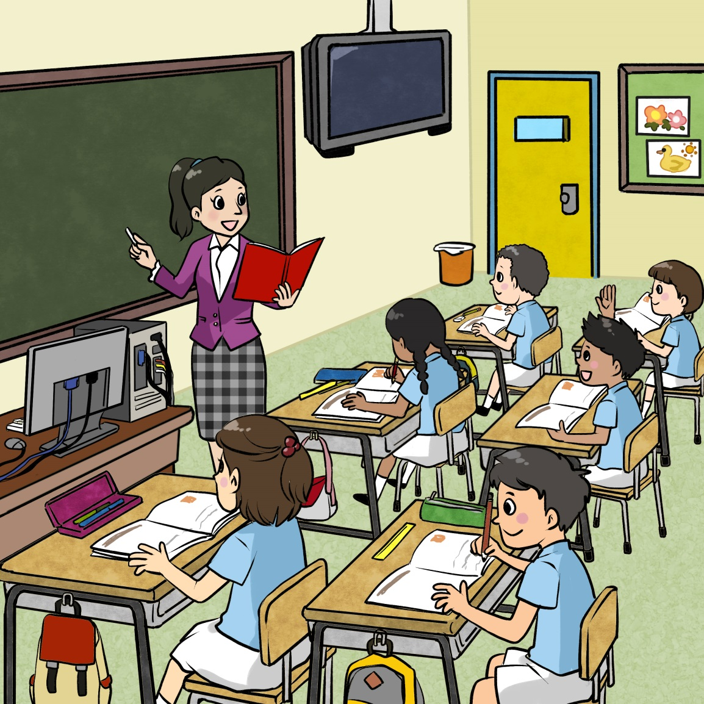**第一課　我的學校**

姓名：\_\_\_\_\_\_\_\_ 班級：\_\_\_\_\_\_\_\_\_

**(一) 學校有：**

**一、看一看，説一説**

|  |  |
| --- | --- |
| C:\Documents and Settings\chiuyan\My Documents\Betty Chiu\齊齊說\Artwork\P09_01.jpg | C:\Documents and Settings\chiuyan\My Documents\Betty Chiu\齊齊說\Artwork\P09_03.jpg |
|  | C:\Documents and Settings\chiuyan\My Documents\Betty Chiu\齊齊說\Artwork\P09_05.jpg |

**二、 聽一聽，連一連**



**…**.

|  |  |  |  |
| --- | --- | --- | --- |
| 校長 | 老師 | 校工 | 同學 |
|  |  |  |  |
|  |  |  |  |
|  | C:\Documents and Settings\chiuyan\My Documents\Betty Chiu\齊齊說\Artwork\P09_05.jpg | C:\Documents and Settings\chiuyan\My Documents\Betty Chiu\齊齊說\Artwork\P09_03.jpg | C:\Documents and Settings\chiuyan\My Documents\Betty Chiu\齊齊說\Artwork\P09_01.jpg |

**三、説一説**

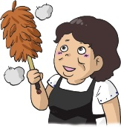

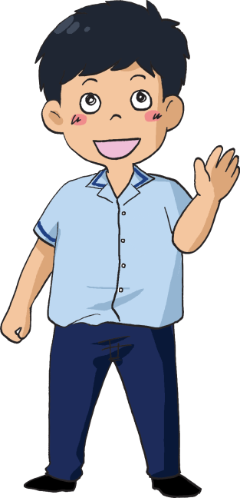

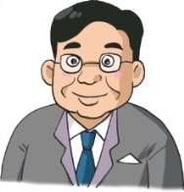

**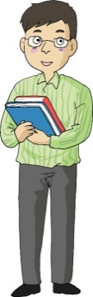**

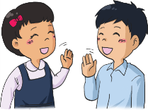

**(二) 學校有：**

**一、看一看，説一説**

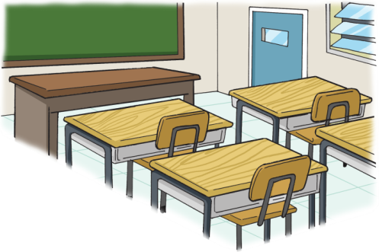

|  |  |  |
| --- | --- | --- |
| C:\Documents and Settings\chiuyan\My Documents\Betty Chiu\八鄉_齊齊說\P17_04.png | C:\Users\edbuser\Desktop\Pictures_L&T_A Tool\color\LSTH\第一冊\圖part1\01_14e.jpg  課室      操場    洗手間  01_14g_調整大小    禮堂  教員室 |  |
| 圖書館 |  |
| 音樂室 |  |
| **C:\Users\edbuser\Desktop\聽聽說說related pic\8.jpg** |  |
|  |  |
|  |  |

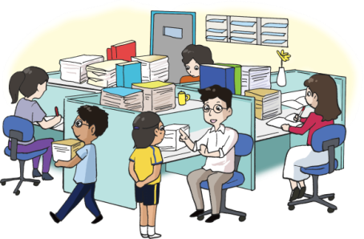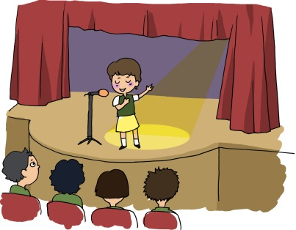

**二、 聽一聽，圈一圈**

**…**.

|  |  |  |
| --- | --- | --- |
| **例子**  **課室** | C:\Users\edbuser\Desktop\Pictures_L&T_A Tool\color\LSTH\第一冊\圖part1\01_14f.jpg | C:\Documents and Settings\chiuyan\My Documents\Betty Chiu\八鄉_齊齊說\P21_01.png |
| **1** | 01_14g_調整大小 | C:\Users\edbuser\Desktop\Pictures_L&T_A Tool\color\LSTH\第一冊\圖part1\01_14e.jpg |
| **2** | **C:\Users\edbuser\Desktop\聽聽說說related pic\8.jpg** | C:\Documents and Settings\chiuyan\My Documents\Betty Chiu\八鄉_齊齊說\P17_04.png |
| **3** | 01_14g_調整大小 | C:\Documents and Settings\chiuyan\My Documents\Betty Chiu\八鄉_齊齊說\P17_05.png |
| **4** | C:\Users\edbuser\Desktop\Pictures_L&T_A Tool\color\LSTH\第一冊\圖part1\01_14e.jpg | C:\Users\edbuser\Desktop\Pictures_L&T_A Tool\color\LSTH\第一冊\圖part1\01_14f.jpg |
| **5** | C:\Documents and Settings\chiuyan\My Documents\Betty Chiu\八鄉_齊齊說\P17_05.png | **C:\Users\edbuser\Desktop\聽聽說說related pic\8.jpg** |

**三、説一説**

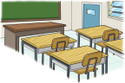

一年級的課室

**在哪裏？**

一年級的課室

**在**二樓。

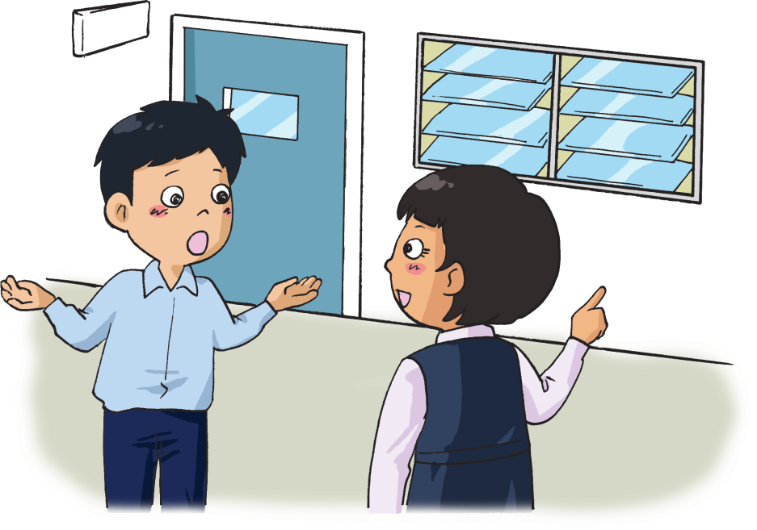

|  |  |  |
| --- | --- | --- |
| C:\Documents and Settings\chiuyan\My Documents\Betty Chiu\八鄉_齊齊說\P17_05.png | **C:\Users\edbuser\Desktop\聽聽說說related pic\8.jpg** | C:\Users\edbuser\Desktop\Pictures_L&T_A Tool\color\LSTH\第一冊\圖part1\01_14e.jpg |
| C:\Documents and Settings\chiuyan\My Documents\Betty Chiu\八鄉_齊齊說\P17_04.png | 01_14g_調整大小 | C:\Users\edbuser\Desktop\Pictures_L&T_A Tool\color\LSTH\第一冊\圖part1\01_14f.jpg |

**四、問一問**

可以。

**老師，請問我可以**去洗手間**嗎？**

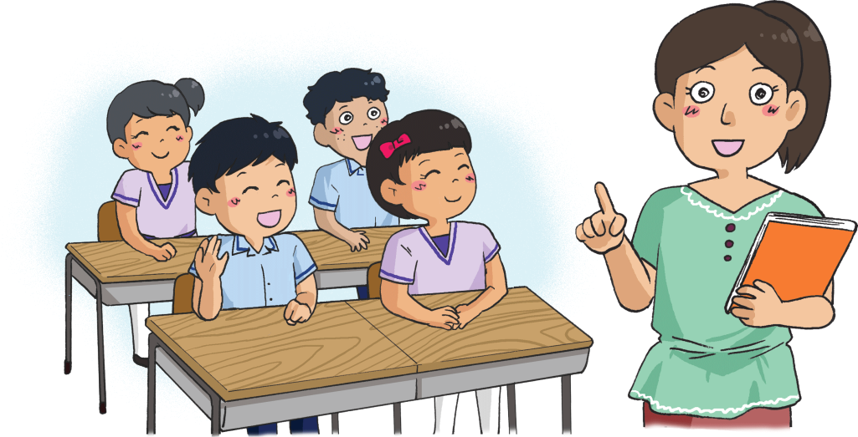

|  |  |
| --- | --- |
| C:\Documents and Settings\chiuyan\My Documents\Betty Chiu\八鄉_齊齊說\P33_05.png | C:\Users\edbuser\Desktop\Pictures_L&T_A Tool\color\Modules_pri_2014\3a\2014.5.12_15\3a_002.jpg |
| C:\Users\edbuser\Desktop\聽聽說說related pic\13.pngC:\Users\edbuser\Desktop\聽聽說說related pic\11_48c.jpg | C:\Users\edbuser\Desktop\聽聽說說related pic\11_56a.jpgC:\Users\edbuser\Desktop\聽聽說說related pic\11_48c.jpg |

**(三) 上課了**

**一、**圈一圈，你今天上了哪些課？

|  |  |
| --- | --- |
| C:\Users\edbuser\Desktop\聽聽說說related pic\4.jpg | C:\Users\edbuser\Desktop\聽聽說說related pic\5.jpg |
| 中文 | 英文 |
| C:\Users\edbuser\Desktop\聽聽說說related pic\1.jpg | C:\Users\edbuser\Desktop\聽聽說說related pic\6.jpg |
| 數學 | 常識 |
| C:\Users\edbuser\Desktop\聽聽說說related pic\7.jpg | **C:\Users\edbuser\Desktop\聽聽說說related pic\8.jpg** |
| 視藝 | 音樂 |
| C:\Users\edbuser\Desktop\聽聽說說related pic\16.jpg | C:\Users\edbuser\Desktop\聽聽說說related pic\10.jpg |
| 圖書 | 體育 |
| C:\Users\edbuser\Desktop\聽聽說說related pic\9.jpg |
| 電腦 |

**二、説一説**

**我喜歡**中文。

**你喜歡甚麼科目？**

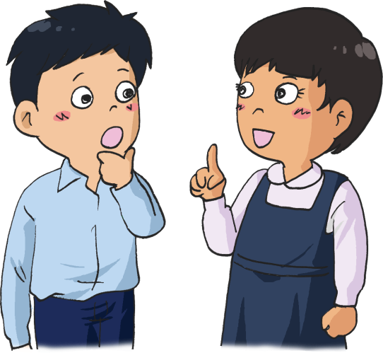

|  |  |  |
| --- | --- | --- |
| C:\Users\edbuser\Desktop\聽聽說說related pic\5.jpg | C:\Users\edbuser\Desktop\聽聽說說related pic\1.jpg | C:\Users\edbuser\Desktop\聽聽說說related pic\6.jpg |
| **C:\Users\edbuser\Desktop\聽聽說說related pic\8.jpg** | C:\Users\edbuser\Desktop\聽聽說說related pic\10.jpg | C:\Users\edbuser\Desktop\聽聽說說related pic\9.jpg |

**(四) 課室有：**

**一、看一看，説一説**

**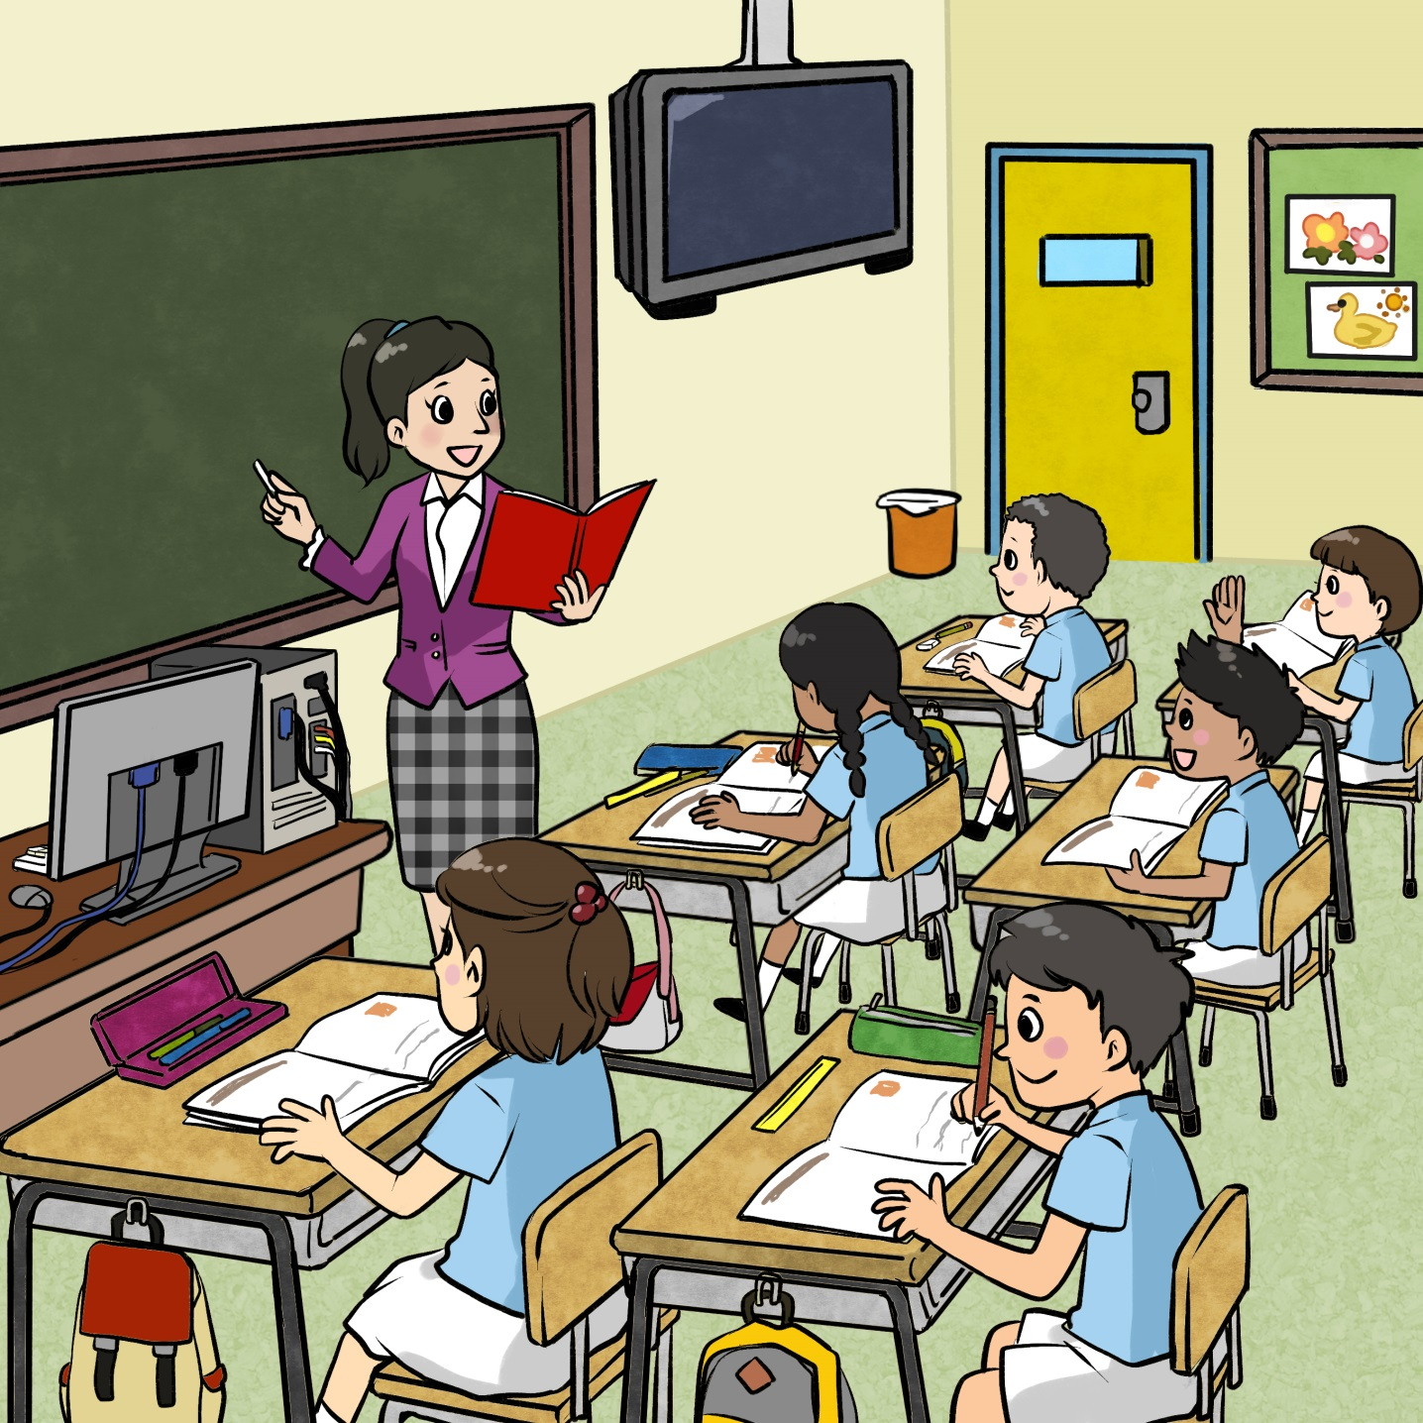**

****

**…**.

**二、 聽一聽、連一連**

**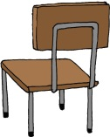**

|  |  |  |  |  |
| --- | --- | --- | --- | --- |
| **黑板** |  |  |  | **C:\Users\edbuser\Desktop\Pictures_L&T_A Tool\color\LSTH\Amendments\11c\11_47a.jpg** |
| **壁報** |  |  |  | **C:\Users\edbuser\Desktop\Pictures_L&T_A Tool\color\LSTH\Amendments\11b\11_38e.jpg** |
| **椅子** |  |  |  | **C:\Users\edbuser\Desktop\self draw\d5.jpg** |
| **桌子** |  |  |  | **2_9_59_0_0** |
| **電視** |  |  |  | **C:\Users\edbuser\Desktop\Pictures_L&T_A Tool\color\LSTH\Amendments\11b\11_38a.jpg** |
| **電腦** |  |  |  |  |

**(五) 我的書包**

**一、畫一畫：書包裏有甚麼？**

**二、説一説**

**我的書包裏有**

課本、鉛筆和雨傘。

**你的書包裏**

**有甚麼？**

