中國語文（一）

（非華語學生適用）

課冊

**第四課　小牛在哪裏？**

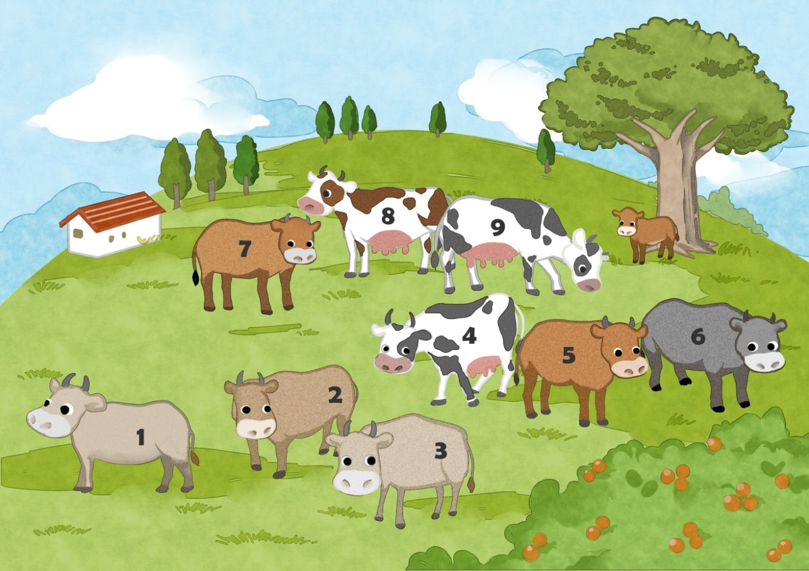

姓名：\_\_\_\_\_\_\_\_ 班級：\_\_\_\_\_\_\_\_\_

**(一) 看一看，説一説**

|  |  |  |  |
| --- | --- | --- | --- |
| C:\Users\edbuser\Desktop\Pictures_L&T_A Tool\color\LSTH\Amendments\090318 reviseA\01_08d_revise01.jpg | C:\Users\edbuser\Desktop\Pictures_L&T_A Tool\color\LSTH\第三冊\03\03_24a.jpgC:\Users\edbuser\Desktop\Pictures_L&T_A Tool\color\LSTH\第三冊\03\03_24a.jpg | 2_4_51_0_0 | C:\Users\edbuser\Desktop\Pictures_L&T_A Tool\color\LSTH\第七冊\07\07_011a.jpgC:\Users\edbuser\Desktop\Pictures_L&T_A Tool\color\LSTH\第七冊\07\07_011a.jpg |
| 一 | 二 | 三 | 四 |
| C:\Users\edbuser\Desktop\Pictures_L&T_A Tool\color\LSTH\第五冊\05\05_15b.jpg | C:\Users\edbuser\Desktop\Pictures_L&T_A Tool\color\LSTH\第四冊\04c\04_31a.jpgC:\Users\edbuser\Desktop\Pictures_L&T_A Tool\color\LSTH\第四冊\04c\04_31a.jpgC:\Users\edbuser\Desktop\Pictures_L&T_A Tool\color\LSTH\第四冊\04c\04_31a.jpg | C:\Users\edbuser\Desktop\Pictures_L&T_A Tool\color\LSTH\Amendments\11a\11_09d.jpgC:\Users\edbuser\Desktop\Pictures_L&T_A Tool\color\LSTH\Amendments\11a\11_09d.jpgC:\Users\edbuser\Desktop\Pictures_L&T_A Tool\color\LSTH\Amendments\11a\11_09d.jpgC:\Users\edbuser\Desktop\Pictures_L&T_A Tool\color\LSTH\Amendments\11a\11_09d.jpgC:\Users\edbuser\Desktop\Pictures_L&T_A Tool\color\LSTH\Amendments\11a\11_09d.jpgC:\Users\edbuser\Desktop\Pictures_L&T_A Tool\color\LSTH\Amendments\11a\11_09d.jpgC:\Users\edbuser\Desktop\Pictures_L&T_A Tool\color\LSTH\Amendments\11a\11_09d.jpg | C:\Users\edbuser\Desktop\Pictures_L&T_A Tool\color\LSTH\Amendments\11c\11_58c.jpgC:\Users\edbuser\Desktop\Pictures_L&T_A Tool\color\LSTH\Amendments\11c\11_58c.jpg |
| 五 | 六 | 七 | 八 |
| C:\Users\edbuser\Desktop\Pictures_L&T_A Tool\color\LSTH\第一冊\圖part1\01_08g.jpg | C:\Users\edbuser\Desktop\Pictures_L&T_A Tool\color\LSTH\第九冊\09\09_11a.jpgC:\Users\edbuser\Desktop\Pictures_L&T_A Tool\color\LSTH\第九冊\09\09_11a.jpg | C:\Users\edbuser\Desktop\1.jpg | 2_5_73_0_0 |
| 九 | 十 | 上面 | 下面 |
|  | C:\Users\edbuser\Desktop\b2.jpg | C:\Users\edbuser\Desktop\b1.jpg |
| 中間 | 左面 | 右面 |

**(二) 課文**

**小牛在哪裏？**

山上有十頭牛。

左看看，一、二、三，

左面有三頭牛。

右看看，四、五、六，

右面有三頭牛。

再看一看，七、八、九，

中間有三頭牛。

還有一頭小牛呢？

牠在大樹下。

**一、考考你**

**聽一聽，圈一圈**

1. A. 九 B. 六 C. 十

2. A. 山上 B. 樹下 C. 草地上

**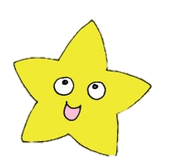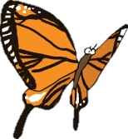數一數，填一填**

|  |  |  |  |  |  |  |
| --- | --- | --- | --- | --- | --- | --- |
|  |  | C:\Users\edbuser\Desktop\Pictures_L&T_A Tool\color\LSTH\第七冊\07\07_040a.jpg |  |  |  | C:\Users\edbuser\Desktop\Pictures_L&T_A Tool\color\LSTH\第七冊\07\07_040a.jpg |
| C:\Users\edbuser\Desktop\Pictures_L&T_A Tool\color\LSTH\第二冊\02a\02_17b.jpg | C:\Users\edbuser\Desktop\Pictures_L&T_A Tool\color\LSTH\第二冊\02a\02_17b.jpg | C:\Users\edbuser\Desktop\Pictures_L&T_A Tool\color\LSTH\Amendments\11b\11_45d.jpgC:\Users\edbuser\Desktop\Pictures_L&T_A Tool\color\LSTH\第二冊\02a\02_21a.jpg | C:\Users\edbuser\Desktop\Pictures_L&T_A Tool\color\LSTH\第二冊\02a\02_21a.jpg | C:\Users\edbuser\Desktop\Pictures_L&T_A Tool\color\LSTH\第一冊\圖part1\01_08h.jpg | C:\Users\edbuser\Desktop\Pictures_L&T_A Tool\color\LSTH\第一冊\圖part1\01_08h.jpgC:\Users\edbuser\Desktop\Pictures_L&T_A Tool\color\LSTH\Amendments\11b\11_45d.jpg | C:\Users\edbuser\Desktop\Pictures_L&T_A Tool\color\LSTH\第二冊\02a\02_17b.jpg |
| C:\Users\edbuser\Desktop\未命名.jpg | C:\Users\edbuser\Desktop\Pictures_L&T_A Tool\color\LSTH\Amendments\11b\11_45d.jpg | C:\Users\edbuser\Desktop\未命名.jpg | C:\Users\edbuser\Desktop\未命名.jpgC:\Users\edbuser\Desktop\Pictures_L&T_A Tool\color\LSTH\Amendments\11b\11_45d.jpg | C:\Users\edbuser\Desktop\未命名.jpg | C:\Users\edbuser\Desktop\未命名.jpg |  |
|  | C:\Users\edbuser\Desktop\未命名.jpgC:\Users\edbuser\Desktop\Pictures_L&T_A Tool\color\LSTH\第二冊\02a\02_17b.jpg |  |  | C:\Users\edbuser\Desktop\Pictures_L&T_A Tool\color\LSTH\第二冊\02a\02_17b.jpg |  | C:\Users\edbuser\Desktop\未命名.jpg |
| C:\Users\edbuser\Desktop\Pictures_L&T_A Tool\color\LSTH\第一冊\圖part1\01_08h.jpgC:\Users\edbuser\Desktop\Pictures_L&T_A Tool\color\LSTH\Amendments\11b\11_45d.jpg | C:\Users\edbuser\Desktop\Pictures_L&T_A Tool\color\LSTH\第一冊\圖part1\01_08h.jpg | C:\Users\edbuser\Desktop\Pictures_L&T_A Tool\color\LSTH\第二冊\02a\02_21a.jpgC:\Users\edbuser\Desktop\Pictures_L&T_A Tool\color\LSTH\第一冊\圖part1\01_08h.jpg | C:\Users\edbuser\Desktop\Pictures_L&T_A Tool\color\LSTH\Amendments\11b\11_45d.jpg | C:\Users\edbuser\Desktop\Pictures_L&T_A Tool\color\LSTH\第一冊\圖part1\01_08h.jpg | C:\Users\edbuser\Desktop\Pictures_L&T_A Tool\color\LSTH\第二冊\02a\02_21a.jpgC:\Users\edbuser\Desktop\Pictures_L&T_A Tool\color\LSTH\第一冊\圖part1\01_08h.jpg | C:\Users\edbuser\Desktop\Pictures_L&T_A Tool\color\LSTH\第一冊\圖part1\01_08h.jpgC:\Users\edbuser\Desktop\Pictures_L&T_A Tool\color\LSTH\Amendments\11b\11_45d.jpg |
|  |  |  | C:\Users\edbuser\Desktop\Pictures_L&T_A Tool\color\LSTH\Amendments\11b\11_45d.jpg |  |  |  |

|  |  |  |  |
| --- | --- | --- | --- |
| C:\Users\edbuser\Desktop\Pictures_L&T_A Tool\color\LSTH\第二冊\02a\02_21a.jpg例子： |  | C:\Users\edbuser\Desktop\未命名.jpg |  |
| C:\Users\edbuser\Desktop\Pictures_L&T_A Tool\color\LSTH\第一冊\圖part1\01_08h.jpg |  | C:\Users\edbuser\Desktop\Pictures_L&T_A Tool\color\LSTH\第二冊\02a\02_17b.jpg |  |
| C:\Users\edbuser\Desktop\Pictures_L&T_A Tool\color\LSTH\第七冊\07\07_040a.jpg |  | C:\Users\edbuser\Desktop\Pictures_L&T_A Tool\color\LSTH\Amendments\11b\11_45d.jpg |  |

**説一説**

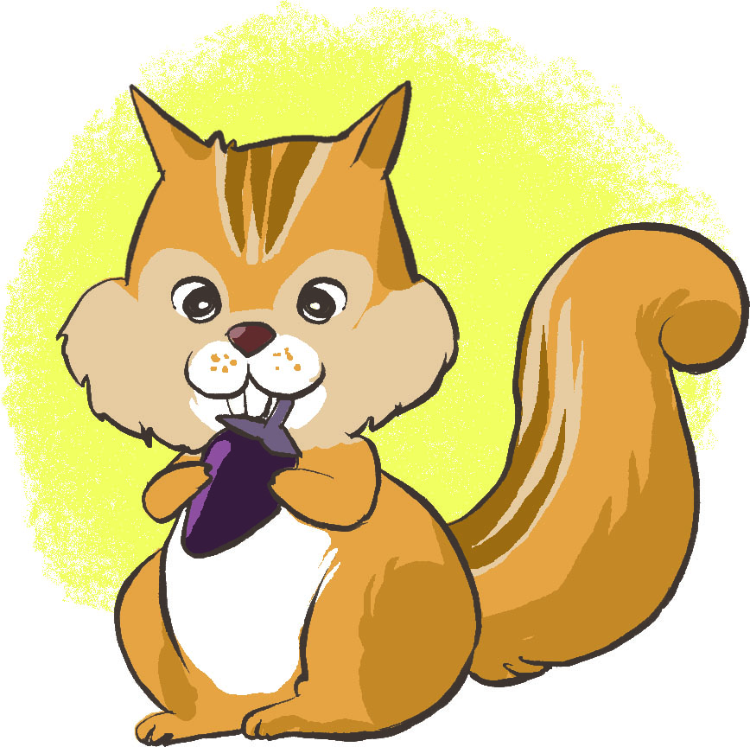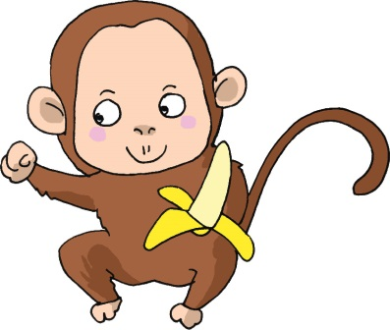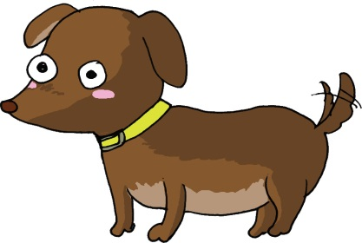

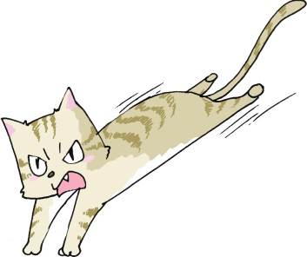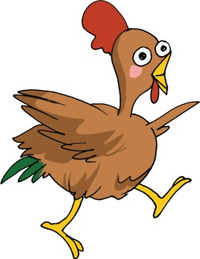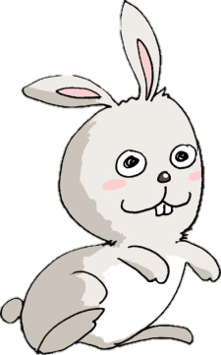

**二、我會用**

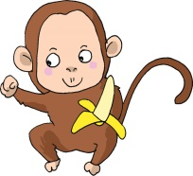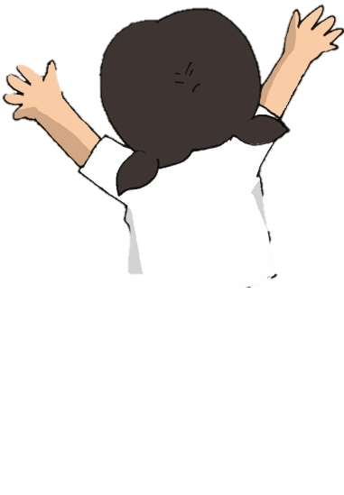

右

上

左

左 中 右

下

**填一填**

|  |  |  |
| --- | --- | --- |
|  | 2_4_61_0_0 |  |
|  | **( )** |  |
| C:\Users\edbuser\Desktop\Pictures_L&T_A Tool\color\LSTH\Amendments\11a\11_27b.jpg | D:\NCS\Modules 2014\pics\140304Lai\1b_031.jpg | C:\Users\edbuser\Desktop\Pictures_L&T_A Tool\color\LSTH\第三冊\03\03_34a.jpg |
| **( )** | **( 中 )** | **( )** |
|  | 1_1_05_0_0 |  |
|  | **( )** |  |

**三、我會用**

|  |  |
| --- | --- |
| C:\Users\edbuser\Desktop\Pictures_L&T_A Tool\color\LSTH\Amendments\11c\11_53b.jpgC:\Users\edbuser\Desktop\Pictures_L&T_A Tool\color\LSTH\Amendments\090318 reviseA\01_08d_revise01.jpg | 一 **頭** 牛  一 **頭** 羊 |
|  |  |
| 2_2_23_0_03_4_56_0_0 | 一 **棵** 樹  D:\形音義\#Grapheme Form of characters\# Converted_Final_for use\Converted-3001-4000_final\3491.jpg一 **棵** |

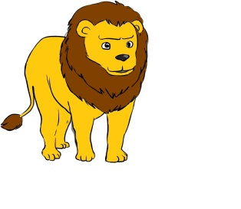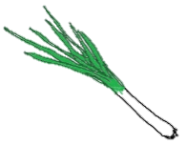**圈一圈**

1. 一 頭 / 棵 2. 一 頭 / 棵

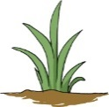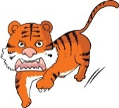

3. 一 頭 / 棵 4. 一頭 / 棵

**四、我會用**

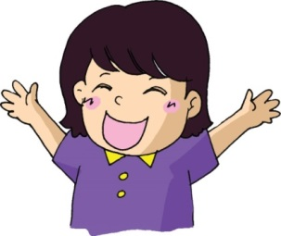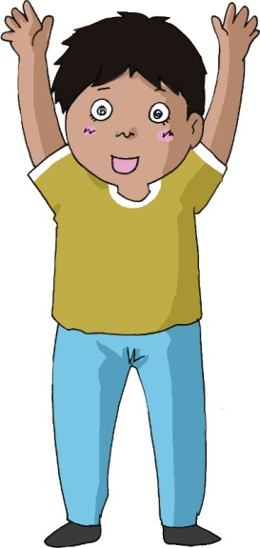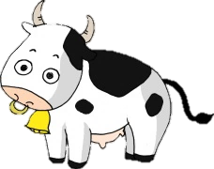



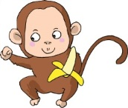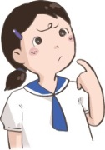 **圈一圈**

1.他 / 她 2. 牠 / 它

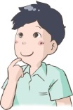

3.牠 / 它 4. 他 / 她

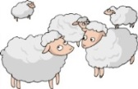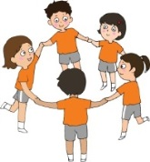

5.他們 / 牠們 6.他們 / 牠們

**(三) 學句子**

中間

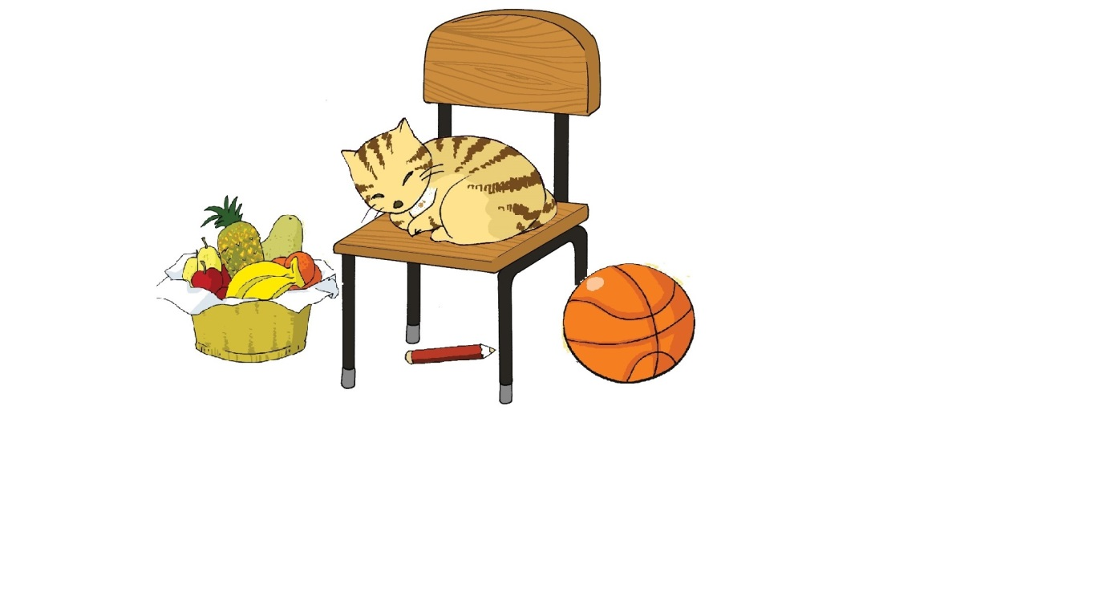

上面

左面

右面

下面

|  |  |
| --- | --- |
| G:\^NCS-小學學習材料\Pictures\Pictures_for new units\middle (2).jpg | 椅子在中間。 |
| G:\^NCS-小學學習材料\Pictures\Pictures_for new units\up.jpg | 小貓在椅子上面。 |
| G:\^NCS-小學學習材料\Pictures\Pictures_for new units\under (2).jpg | 鉛筆在椅子下面。 |
| G:\^NCS-小學學習材料\Pictures\Pictures_for new units\left.jpg | 水果在椅子左面。 |
| G:\^NCS-小學學習材料\Pictures\Pictures_for new units\right.jpg | 皮球在椅子右面。 |

**一、圈一圈**

|  |  |
| --- | --- |
| C:\Users\leeyingying\Desktop\rabbit4.jpg1. | 白兔在椅子 (上/下/左/右) 面。 |
| **C:\Users\leeyingying\Desktop\rabbit.jpg**2. | 白兔在椅子 (上/下/左/右) 面。 |
| C:\Users\leeyingying\Desktop\rabbit3.jpg3. | 白兔在椅子 (上/下/左/右) 面。 |
| C:\Users\leeyingying\Desktop\rabbit2.jpg4. | 白兔在椅子 (上/下/左/右) 面。 |

**二、説一説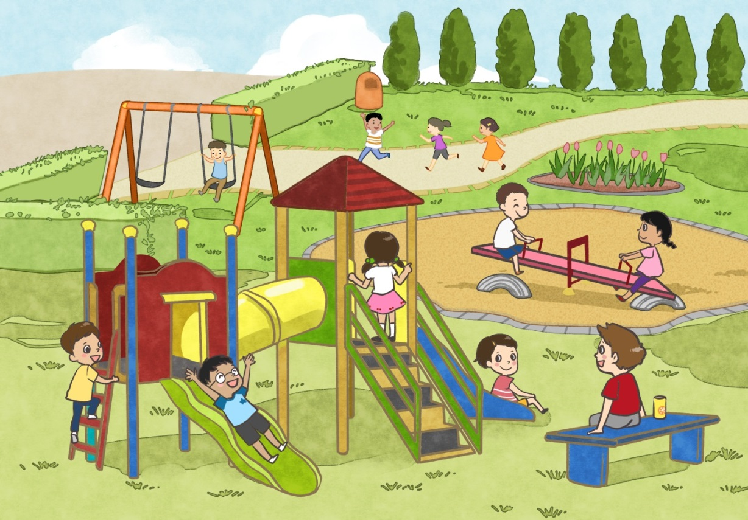**

**(四) 學字詞**

**一、看一看**

左中右結構

例子： 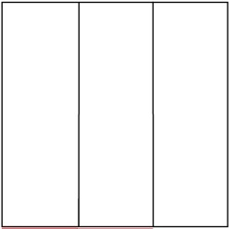樹 哪

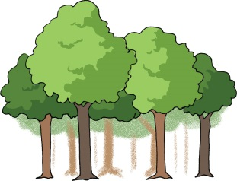

**二、看一看，想一想**

1.

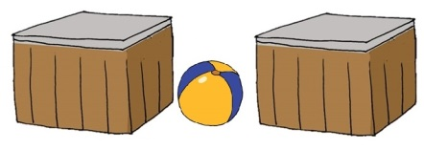門 日 = 間

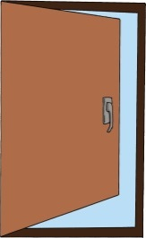

門 开 = 開



 門 口 = 問

2.

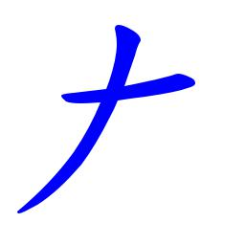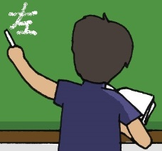

工 = 左

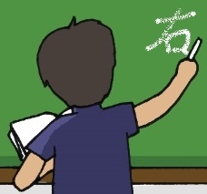

口 = 右

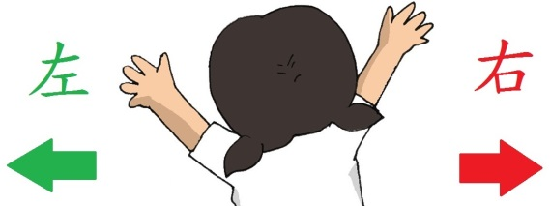

C:\Users\edbuser\Desktop\Pictures_L&T_A Tool\color\LSTH\Amendments\11b\11_41b.jpg**三、寫一寫，讀一讀**

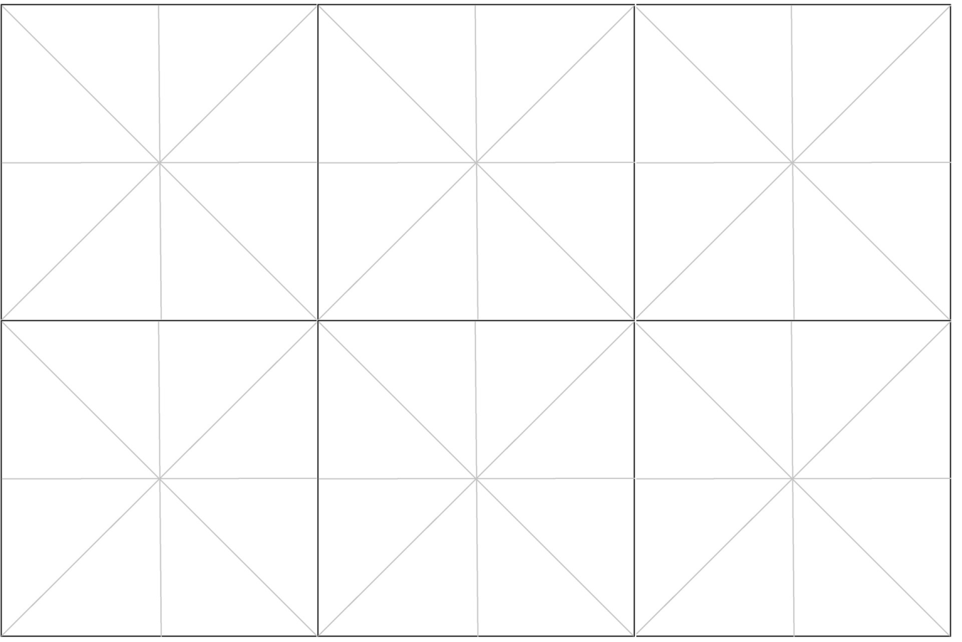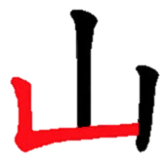

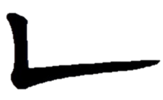

①

②

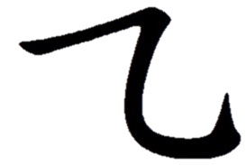

①

②



①

②

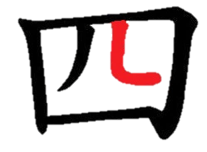

**想一想**

|  |  |  |
| --- | --- | --- |
| 吃  西 | 母  匹 |  |

C:\Users\edbuser\Desktop\a.jpg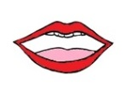寫

|  |  |  |  |
| --- | --- | --- | --- |
| 一 |  | ( ) |  |
|  | C:\Users\edbuser\Desktop\a.jpg | C:\Users\edbuser\Desktop\8-6\word\ch3\ch3-1.jpg | |
| 二 |  | ( ) |  |
|  | C:\Users\edbuser\Desktop\a.jpg | C:\Users\edbuser\Desktop\8-6\word\ch3\ch3-2.jpg | |
| 三 |  | ( ) |  |
|  | C:\Users\edbuser\Desktop\a.jpg | C:\Users\edbuser\Desktop\8-6\word\ch3\ch3-3.jpg | |
| 四 |  | ( ) |  |
|  | C:\Users\edbuser\Desktop\a.jpg | C:\Users\edbuser\Desktop\8-6\word\ch3\ch3-4.jpg | |
| 五 |  | ( ) |  |
|  | C:\Users\edbuser\Desktop\a.jpg | C:\Users\edbuser\Desktop\8-6\word\ch3\ch3-5.jpg | |
| 六 |  | ( ) |  |
|  | C:\Users\edbuser\Desktop\a.jpg | C:\Users\edbuser\Desktop\8-6\word\ch3\ch3-6.jpg | |
| 七 |  | ( ) |  |
|  | C:\Users\edbuser\Desktop\a.jpg | C:\Users\edbuser\Desktop\8-6\word\ch3\ch3-7.jpg | |
| 八 |  | ( ) |  |
|  | C:\Users\edbuser\Desktop\a.jpg | C:\Users\edbuser\Desktop\8-6\word\ch3\ch3-8.jpg | |
| 九 |  | ( ) |  |
|  | C:\Users\edbuser\Desktop\a.jpg | C:\Users\edbuser\Desktop\8-6\word\ch3\ch3-9.jpg | |
| 十 |  | ( ) |  |
|  | C:\Users\edbuser\Desktop\a.jpg | C:\Users\edbuser\Desktop\8-6\word\ch3\ch3-10.jpg | |

|  |  |  |  |
| --- | --- | --- | --- |
| 上 |  | ( ) | 上面、上課 |
|  | C:\Users\edbuser\Desktop\a.jpg | C:\Users\edbuser\Desktop\8-6\word\ch3\ch3-11.jpg | |
| 下 |  | ( ) | 下面、下雨 |
|  | C:\Users\edbuser\Desktop\a.jpg | C:\Users\edbuser\Desktop\8-6\word\ch3\ch3-12.jpg | |
| 中 |  | ( ) | 中國、中文 |
|  | C:\Users\edbuser\Desktop\a.jpg | C:\Users\edbuser\Desktop\8-6\word\ch3\ch3-13.jpg | |
| 左 |  | ( ) | 左面 |
|  | C:\Users\edbuser\Desktop\a.jpg | C:\Users\edbuser\Desktop\8-6\word\ch3\ch3-14.jpg | |
| 右 |  | ( ) | 右面 |
|  | C:\Users\edbuser\Desktop\a.jpg | C:\Users\edbuser\Desktop\8-6\word\ch3\ch3-15.jpg | |

**(五) 我學會了**

**一、連一連**

|  |  |  |  |  |
| --- | --- | --- | --- | --- |
| 六 |  |  |  | **10** |
| 十 |  |  |  | C:\Users\edbuser\Desktop\12.jpg |
| 中間 |  |  |  | C:\Users\edbuser\Desktop\b2.jpg |
| 上面 |  |  |  | C:\Users\edbuser\Desktop\b1.jpg |
| 左面 |  |  |  | C:\Users\edbuser\Desktop\5.jpg |
| 右面 |  |  |  | **6** |

**二、我學會**

|  |  |
| --- | --- |
| C:\Users\edbuser\Desktop\Pictures_L&T_A Tool\color\LSTH\Amendments\11b\11_39a.jpg | C:\Users\edbuser\Desktop\14.jpg |
| 一 | 二 |
| C:\Users\edbuser\Desktop\Pictures_L&T_A Tool\color\LSTH\Amendments\11b\11_30c.jpg | C:\Users\edbuser\Desktop\Pictures_L&T_A Tool\color\LSTH\Amendments\11b\11_42a.jpg |
| 三 | 四 |
| C:\Users\edbuser\Desktop\15.jpg | C:\Users\edbuser\Desktop\self draw\b16.jpg |
| 五 | 六 |
| C:\Users\edbuser\Desktop\Pictures_L&T_A Tool\color\LSTH\Amendments\11b\11_39b.jpg | C:\Users\edbuser\Desktop\Pictures_L&T_A Tool\color\LSTH\Amendments\11b\11_33b.jpg |
| 七 | 八 |
| C:\Users\edbuser\Desktop\self draw\b17.jpg | C:\Users\edbuser\Desktop\Pictures_L&T_A Tool\color\LSTH\Amendments\11b\11_39a.jpg |
| 九 | 十 |
| C:\Users\edbuser\Desktop\5.jpg | C:\Users\edbuser\Desktop\6.jpg |
| 上面 | 下面 |
| C:\Users\edbuser\Desktop\b8.jpg | C:\Users\edbuser\Desktop\b7.jpg |
| 左面 | 右面 |
| C:\Users\edbuser\Desktop\Pictures_L&T_A Tool\color\LSTH\第三冊\03\03_33b.jpg | C:\Users\edbuser\Desktop\Pictures_L&T_A Tool\color\LSTH\第四冊\04a\04_07g.jpg |
| 中間 | 山 |
| C:\Users\edbuser\Desktop\Pictures_L&T_A Tool\color\LSTH\Amendments\11c\11_53a.jpg |  |
| 牛 |  |

**三、我還學會**

|  |  |
| --- | --- |
| C:\Users\edbuser\Desktop\Pictures_L&T_A Tool\color\LSTH\第六冊\06\06_43a.jpg | C:\Users\edbuser\Desktop\Pictures_L&T_A Tool\color\LSTH\第二冊\02b\02_28a.jpg |
| 白兔 | 皮球 |
| 2_7_21_0_0 | C:\Users\edbuser\Desktop\Pictures_L&T_A Tool\color\LSTH\第二冊\02a\02_14c.jpg |
| 開 | 問 |
|  |  |
|  |  |
|  |  |
|  |  |
|  |  |
|  |  |
|  |  |
|  |  |

|  |
| --- |
| C:\Documents and Settings\chiuyan\My Documents\Betty Chiu\Projects\八鄉_齊齊說\Artwork\icon04re01.png |

****

我喜歡這一課。    